**“AI-BASED IMAGE ANALYSIS FOR EARLY DISEASE**

**DETECTION IN MEDICAL IMAGING”**

**A Project Report**

*Submitted in the partial fulfilment for the award of the degree of*

**BACHELOR OF ENGINEERING**

**IN**

**COMPUTER SCIENCE AND ENGINEERING**

**APEX INSTITUTE OF TECHNOLOGY**

**Submitted by:**

| UMA SHANKAR SINGH | 20BCS3789 |
| --- | --- |
|  |  |
|  |  |

**Under the Supervision of:**

**SAKSHI GILL**



**CHANDIGARH UNIVERSITY, GHARUAN, MOHALI - 140413,**

**PUNJAB**

**January -June, 2024**



**BONAFIDE CERTIFICATE**

Certified that this project report **“AI-BASED IMAGE ANALYSIS FOR EARLY DISEASE DETECTION IN MEDICAL IMAGING”** is the bonafide work of **“Uma SHANKAR SINGH (20BCS3789),,** who carried out the project work under my/our supervision.

| **SIGNATURE**  Er. Aman Kaushik  (Apex Institute of Technology -IBM CSE)  **HEADOFTHEDEPARTMENT** | **SIGNATURE**  SAKSHI GILL  (Apex Institute of Technology -IBM  CSE)  **SUPERVISOR** |
| --- | --- |

Submitted for the project viva-voce examination held on 

**INTERNAL EXAMINER EXTERNAL EXAMINER**

**ACKNOWLEDGEMENT**

We would like to earnestly acknowledge the sincere efforts and valuable time given by Assistant Professor Pulkit Dwivedi . Their valuable guidance and feedback have helped us in completing this project. Also, we would like to thank our group members who supported each other in making and completing this project successively. Our sincere efforts finally produced something that we imagined. We would also like to thank faculty who provided us this golden chance. Last but not least we would like to thank everyone who supported and motivated us for pushing ourselves beyond our strength. Thank you.

**TABLE OF CONTENTS**

**List of Figures 6**

**List of Tables 7**

**ABBREVIATIONS 8**

**ABSTRACT 9**

**CHAPTER** -1 **INTRODUCTION 10**

1.1. Machine Learning and Emotion Detection 10

1.1.1. About the Dataset 11

1.1.2. Relevant Approach 13

1.1.3 Transfer Learning 15

1.2. Challenges faced 19

1.3. Related Work 21

**CHAPTER-2 LITERATURE SURVEY 24**

2.1. Existing Solution 24

2.2. Literature Review Summary 27

2.3. Problem Formulation 29

2.4. Goals/Objectives 30

**CHAPTER-3 DESIGN FLOW/ PROCESS 32**

3.1. Evaluation & Selection of Specifications/Features 32

3.2. Design Flow 32

3.3. Design selection 34

3.4. Implementation plan/methodology 35

3.4.1 Data Preparation: 35

3.4.2 Preprocessing: 36

3.4.3 Normalization: 37

3.4.4 Data Augmentation: 37

3.4.5 VGGNet Architecture: 39

3.4.6 Training with Early Stopping: Mitigating Overfitting: 39

3.4.7 Adaptive Learning Rate Adjustment (ReduceLROnPlateau): 40

3.4.8 Optimizing Training With Adam 42

3.4.9 Model Evaluation 42

**CHAPTER-4 RESULTS ANALYSIS AND VALIDATION 46**

4.1 Model Evaluation 46

4.1.1. Confusion matrix metrics 49

4.2. Plots 51

4.2.1. Accuracy 51

4.2.2. Loss 52

4.2.3. Analysis 53

4.3. Real-Time Performance 53

4.3.1 GUI performance 58

**CHAPTER-5 CONCLUSION AND FUTURE WORK 61**

5.1 Conclusion 61

5.2 Future Scope 61

**REFERENCES 63**

# 

# 

# 

# List of Figures

**Figure 1.1: FER-2013 Dataset...............................................................................................................12**

**Figure 1.2: Dataset Emotion Labels..................................................................................................... 13**

**Figure 1.3: CNN Model Architecture...................................................................................................14**

**Figure 1.4: CNN Model Architecture for Emotion Detection............................................................15**

**Figure 1.5: VGG19 Model Architecture............................................................................................. 17**

**Figure 1.6: VGG19 Model Layers........................................................................................................ 18**

**Figure 2.1: Comparative Review of Existing Works...........................................................................25**

**Figure 3.1: Flowchart of the Methodology.......................................................................................... 33**

**Figure 3.2: Augmented Data.................................................................................................................38**

**Figure 3.3: Epoch VS Loss Architecture..............................................................................................41**

**Figure 3.4: Flowchart of Facial Emotion Detection Model...............................................................44**

**Figure 4.1: Confusion Matrix................................................................................................................48**

**Figure 4.2: Confusion Matrix Metrics Result......................................................................................51**

**Figure 4.3: Training VS Validation Accuracy and Loss Graph.........................................................52**

**Figure 4.4: Model Facial Detection Results.........................................................................................55**

**Figure 4.5: Model GUI...........................................................................................................................56**

**Figure 4.6: Emosync GUI......................................................................................................................59**

# 

# List of Tables

**Table 2.1: Literature Review Summary...............................................................................................27**

# ABBREVIATIONS

1. CNN - Convolutional Neural Networks
2. VGG - Visual Geometry Group
3. AI - Artificial Intelligence
4. ML - Machine Learning
5. ICML - International Conference on Machine Learning
6. GUI - Graphical User Interface
7. SIFT - Scale invariant feature transform
8. BOVW - Bag of visual words
9. RESNet - Residual Neural Network
10. SVM - Support Vector Machine
11. CV - Computer Vision

# ABSTRACT

We develop effective medical image classification using segmentation algorithms, and is covered in this work. It is essential for optimal treatment planning and successful patient outcomes that disease are accurately detected. Early disease symptoms are frequently found using magnetic resonance imag ing (MRI) scans, and segmentation is a crucial step in locating the affected location. This study analyses various segmentation methods and assesses how well they work to find several diseases. In locating the affected location, the study illustrates the accuracy of deep learning and segmentation approaches such CNNs. A brand-new hybrid segmentation strategy is also suggested, which mixes many segmentation procedures to provide superior outcomes to those of the individual ones. The most important and trustworthy deep learning architecture for performing semantic segmentation in early disease detection is Efficient-Net (V2).

Index Terms—Segmentation, MRI, Deep Learning, Efficient Net (V2), Disease Detection

# CHAPTER-1 INTRODUCTION

## 1.1. AI-based Image Analysis for Early Disease Detection in Medical Imaging

It is evident from prior years that disease classification and prediction are. To pinpoint the exact cause of an illness as well as its symptoms, one must be familiar with the crucial characteristics and attributes provided in a dataset. Artificial Intelligence (AI) has demonstrated encouraging outcomes in terms of classification and decision support. A subset of arti f icial intelligence called machine learning (ML) has sped up a lot of medical research. Studies conducted from 2014 and the present day cover a wide range of applications and algorithms designed to improve the medical industry by giving patients reliable findings. With the use of data, machine learning (ML) has expanded the limits of science in a number of fields, such as computer vision, automatic speech recognition, and natural language processing, to create reliable systems like automated translation and driverless cars. Despite all of the progress, there are still risks associated with using machine learning in healthcare. Many of these problems arose from the delivery of medical care, where the aim was to use the data gathered and the medical system’s control to make accurate projections.

For effective therapy and patient survival, diseases must be identified early and with precision. Early diseases can be found using MRIs, a popular non- invasive medical imaging technology. Due to the various locations and forms of diseases, it can be difficult and complex to reliably detect and segment body diseases from MRI scans.

The most common approach to early diseases detection and segmentation involves using a combination of pre processing steps, feature extraction techniques, and machine learning techniques. Pre-processing[3] takes into account applying var ious filters and transformations to the MRI images to enhance the contrast between the affected area and healthy tissue. Feature extraction involves identifying specific features of the disease, such as location and intensity, that can be used to distinguish it from the surrounding tissue. Then, using a set of labelled MRI images as training data, machine learning algorithms are trained to identify the patterns that separate the affected area from healthy tissue and forecast the location and area of the disease in new, unlabelled images. The most com mon approach to early diseases detection and segmentation involves using a combination of pre processing steps, feature extraction techniques, and machine learning techniques. Pre processing takes into account applying various filters and transformations to the MRI images to enhance the contrast between the affected area and healthy tissue. Feature extraction involves identifying specific features of the disease, such as location and intensity, that can be used to distinguish it from the surrounding tissue. Then, using a set of labelled MRI images as training data, machine learning algorithms are trained to identify the patterns that separate the affected area from healthy tissue and forecast the location and area of the disease in new, unlabelled images.

Convolutional neural networks (CNN) and other deep learning approaches recently showed promising results in detection and segmentation of diseases like, brain cancers from MRI data. These methods have shown to be quite effective at locating the disease and separating it from healthy tissue structures. They may also shorten the time needed for planning a diagnosis and course of treatment. The findings of this study show the promise of segmentation techniques based on deep learning for enhancing the detection and management of health issues. Other medical imaging applications that call for precise segmentation of structures of interest can use the proposed hybrid segmentation method, which performs better than traditional segmentation methods. This research can aid in the creation of computer-aided diagnosis tools that can help radiologists and physicians diagnose body diseases in a fast and accurate manner.

### About the Dataset

A tool for developing and evaluating machine learning models for illness prediction is the "Disease Doc 2019" dataset on Kaggle.com. There are two CSV files in it: one for testing and one for training. A CSV file consists of 133 columns, of which 132 are the symptoms and the final column is the associated disease. Using this dataset, users can experiment with different machine learning methods to create models that can categorize illnesses according to a set of symptoms.

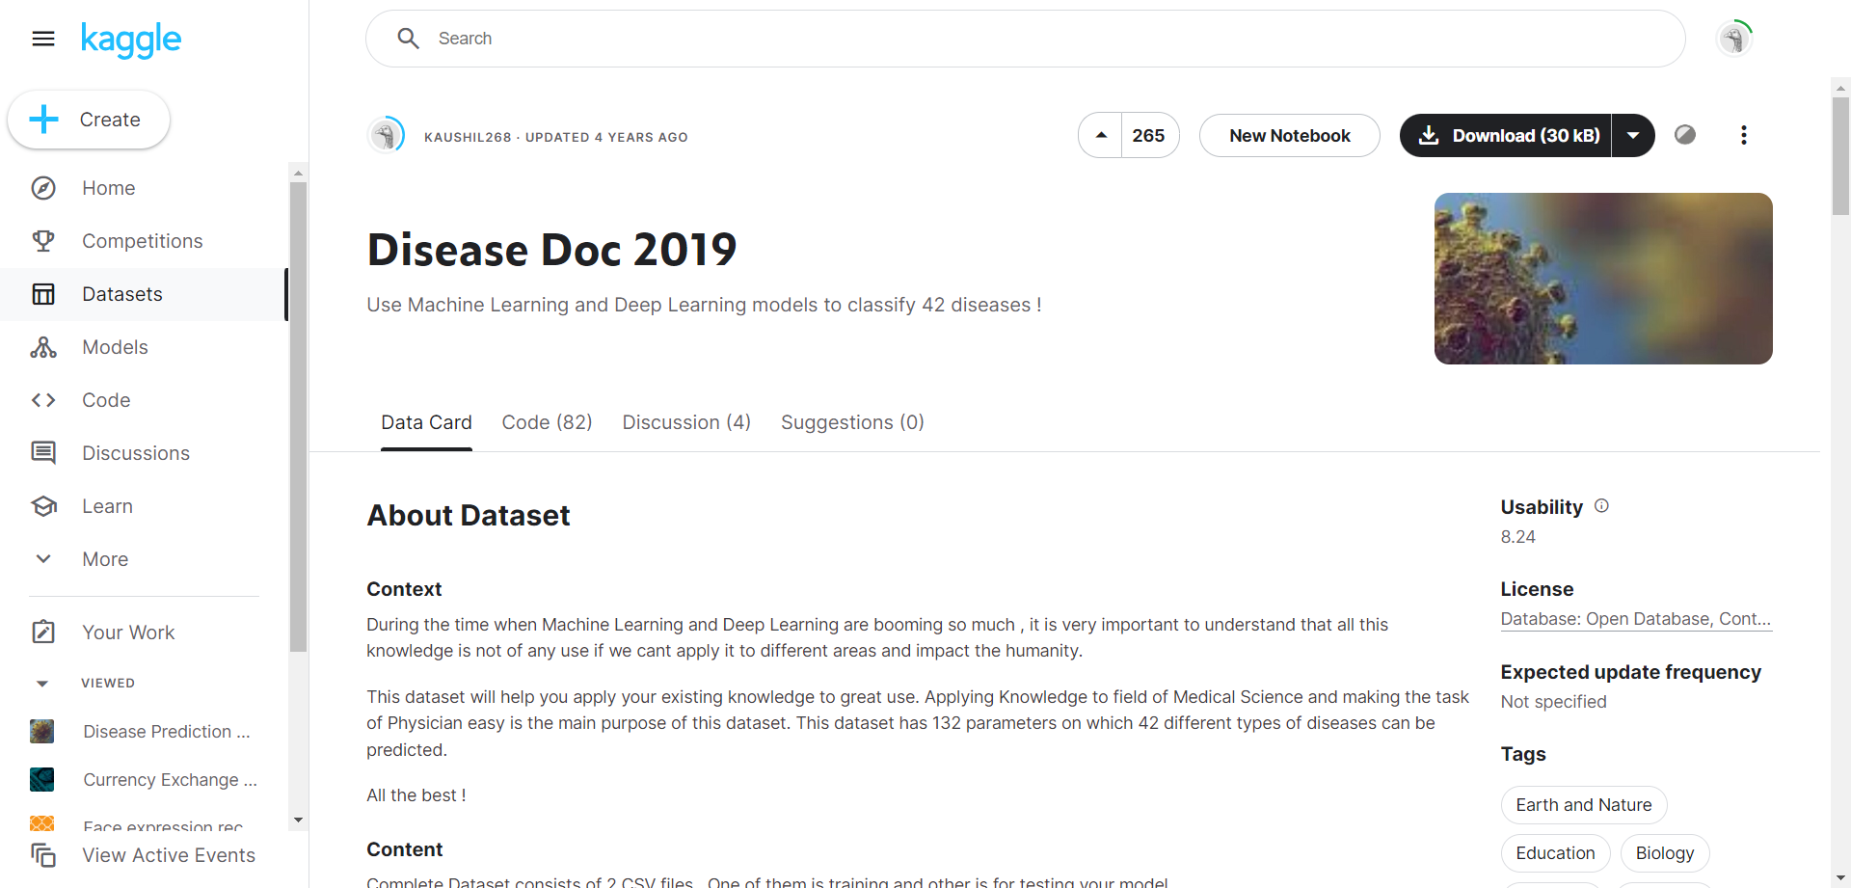

**Figure 1.1: Disease Doc 2019 dataset**

It's vital to take into account certain restrictions even if the "Disease Doc 2019" dataset provides an excellent introduction to illness prediction using machine learning:  
  
1**) Restricted Scope**: This dataset most likely concentrates on a particular group of 42 illnesses and the symptoms that go along with them. In actuality, there are far more diseases, and there is a wide range in symptoms.  
  
2**) Data Origin and Bias**: The dataset may contain bias due to its potential reliance on a specific population group. The model's applicability to different demographics may be impacted by this.

3) **Symptom Representation:** 132 binary values are used in the dataset to indicate symptoms, with 1 indicating a presence and 0 indicating an absence. The format may not properly represent the varied degrees of symptoms found in real-world circumstances.

Not with-standing these drawbacks, the dataset offers a useful foundation for investigating machine learning in the context of illness prediction. It enables users to grasp the fundamental ideas and experiment with various methods. It's crucial to recognize these drawbacks, though, and accept that more intricate models and extensive data are needed for real-world illness prediction.

With an extensive amount of data in it, the following dataset consist of 42 classified diseases in it. It is originally published by KAUSHIL 268 in the year 2019 which includes both testing and training dataset.

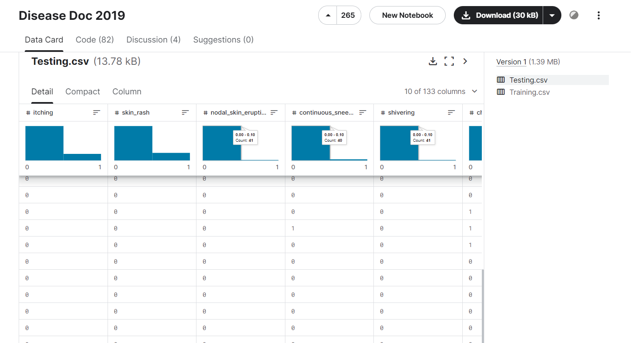

**Figure 1.2: Detailed Description about the Dataset**

The data is probably divided into a training set and a testing set by the "Disease Prediction Using Machine Learning" dataset on Kaggle. This division is essential to the development and assessment of machine learning models.

**Training Set**: The most of the information. With the help of this data, the model is "trained," or made to understand the connections between the 132 columns of symptoms and the related diseases (the last column).

Assume that the model is looking for trends by analyzing previous cases.

The Training dataset consist of 42 different types of symptoms and the diseases are the testing dataset.

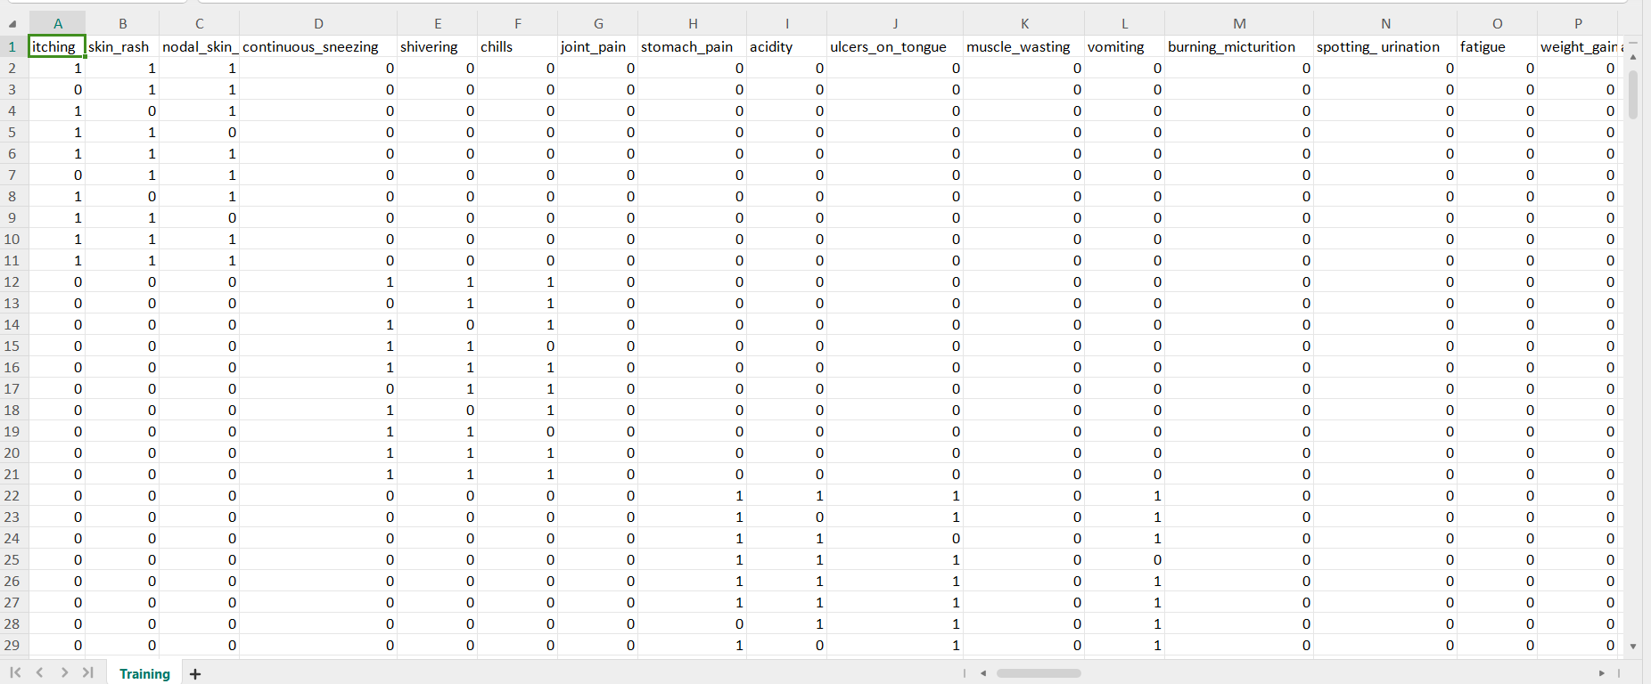

**Figure 1.3: Training Dataset**

**Testing Set**: After training, the model's performance is evaluated using this set of unobserved data. By contrasting the model's predictions with the actual diseases, the accuracy of the model's predictions for the cases in the testing set is determined. By simulating real-world circumstances when the model encounters symptoms that are not yet visible, this helps determine how effectively the model generalizes to new data.

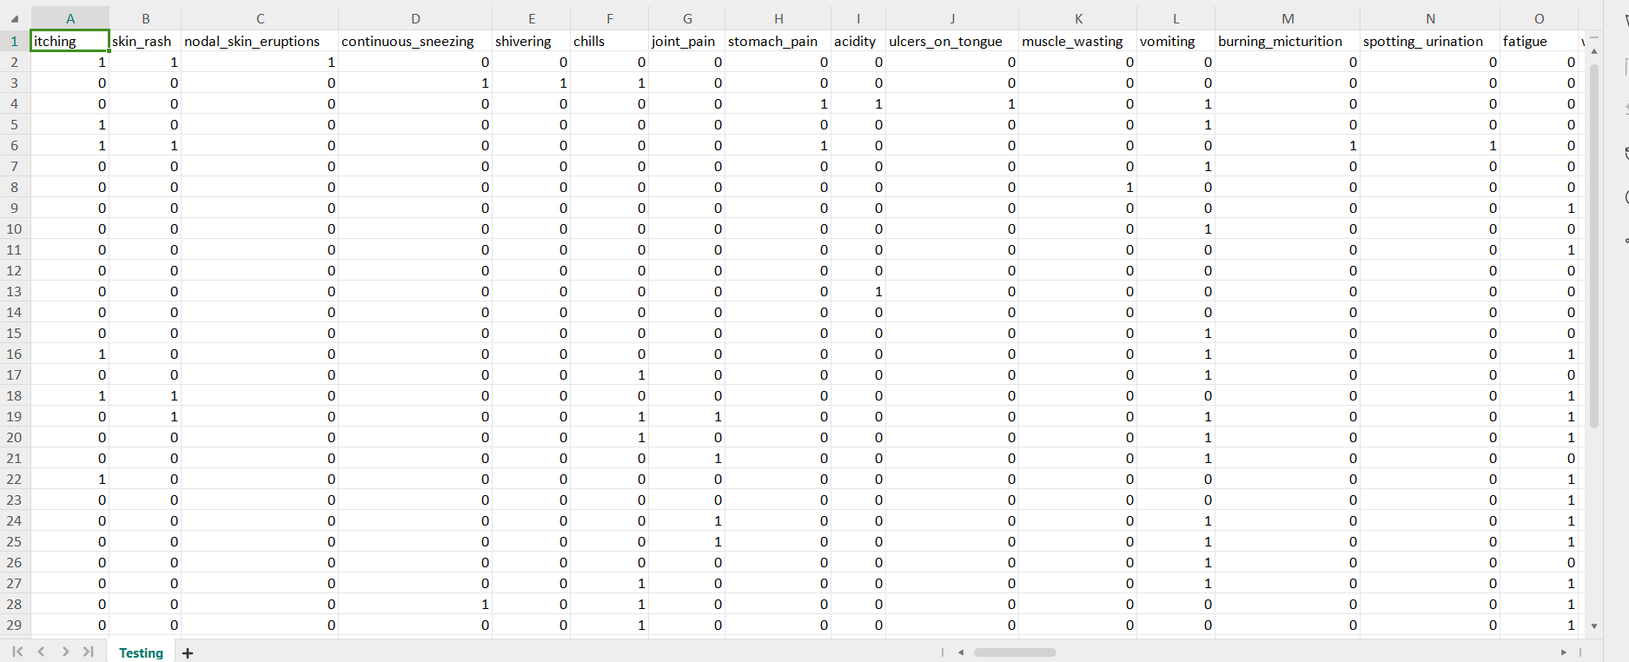

**Figure 1.4: Testing Dataset**

### Relevant Approach

Here we have used a model that predicts the diseases provided the symptoms are given as input to the model. The model consists of four submodels which ensembles together to provide the desired results namely “rf_model_predictio”,”naïve_bayes_prediction”,”svm_model_prediction” and ”final_prediction”. Here are the approaches which are used to build the model:-

* **Preparing data:**

1) Missing Value Handling: The code completely eliminates columns (features) that have missing values by using dropna (axis=1). This presupposes that missing values may be safely eliminated and are not informative.

2) Label Encoding: "Prognosis" (the disease) is the target variable and it is categorical. To provide the machine learning models with numerical labels for these categories (disease names), the code use LabelEncoder.

3) Data Splitting: To divide the data into training and testing sets, the code uses the train_test_split function. The models are trained on the training set, and their performance on unobserved data is assessed on the testing set.

* **Model Construction and Assessment:**

1) Model Selection: Three distinct models for machine learning are employed.

a) Support Vector Machine (SVM): One potent classifier that can learn intricate decision boundaries across many disease categories is the Support Vector Machine (SVM).

b) Gaussian Naive Bayes: This probabilistic classifier makes predictions based on the likelihood of each disease given the symptoms and operates under the assumption that characteristics are independent.

c) Random Forest Classifier: This ensemble model produces predictions that are more reliable by combining several decision trees.

2) Cross-validation: Using a method known as k-fold cross-validation, the code use cross_val_score to assess the models' performance. This aids in estimating the models' generalization ability to new data.

3) Model Training and Evaluation: An accuracy score and confusion matrix are used to assess each model once it has been trained on training data and tested on testing data. The model's ability to distinguish between various diseases is revealed by the confusion matrix.

* **Combining Model Prediction:**

1. Ensemble Prediction: The function “predictDisease”, which accepts symptom names as input, is defined in the code. Next, it employs the SVM, Naive Bayes, and Random Forest models to forecast the disease, with the final prediction being based on the mode of the predictions. By taking into account the majority vote, this method seeks to produce a prediction that is more reliable while utilizing the qualities of each model.

* **Overall Approach:**

1) For categorization problems, this code applies a popular machine learning methodology. Preprocessing the data, training various models, assessing each one's performance, and possibly merging predictions to increase overall accuracy are all part of it.

2) **Vital Points to Remember**:

a) The caliber and volume of the training data have a significant impact on the system's accuracy. Predictions may be skewed or incorrect due to incomplete or unbalanced disease datasets.

b) For the sake of illustration, this model has been simplified. More intricate feature engineering and model selection procedures would probably be used in real-world illness prediction systems.

c) A true medical diagnosis should not be made using this code. It's imperative that you see a doctor about any health issues.

You may determine whether the dataset is balanced or unbalanced by examining the bar plot.

A balanced dataset would show about equal numbers of data points for each ailment, as indicated by the bars' comparable heights.

Unbalanced Dataset: Some diseases would have substantially more data than others, resulting in distinctly differing heights for the bars. Machine learning model performance may be impacted by this imbalance.

**Two such bar plots are produced using the code:**

1. First Plot (noted): This plot probably does a full dataset analysis (using DATA_PATH) prior to any processing. It aids in comprehending the data's initial balance.
2. Plot Following Dropping Missing Values: This plot (using "Training.csv") focuses on the data that was used to train the models. After eliminating rows with missing data (using dropna(axis=1)), it is helpful to evaluate the balance because the disease distribution may be impacted by this preprocessing step. **Figure 1.5: Disease vs Count bar plot**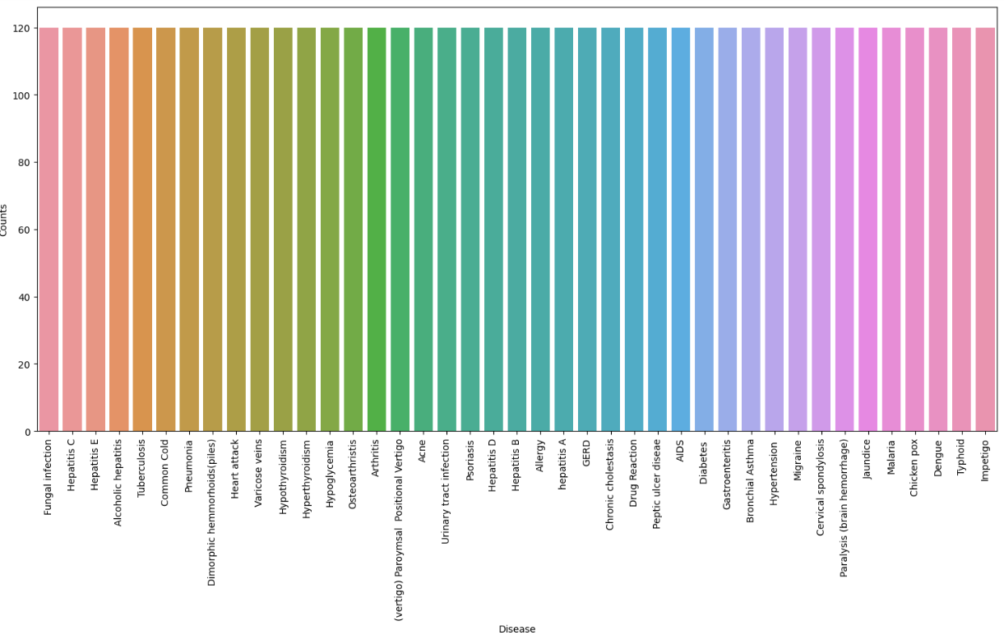

.

### 1.1.3 Muti- Model Architecture

This code predicts diseases using a multi-model architecture. The Support Vector Machine (SVM) [Fig 1.6], Gaussian Naive Bayes[Fig 1.7] , and Random Forest Classifier[Fig 1.8] are the three machine learning models that it trains. In order to find patterns, each model learns from the training data, which consists of disease symptoms and related conditions. The code feeds the three models the symptoms entered by the user during prediction. To get the final disease prognosis, it then integrates the forecasts using the mode, or most frequent prediction. By utilizing the advantages of each individual model, the ensemble technique hopes to increase the overall precision and resilience of the illness prediction.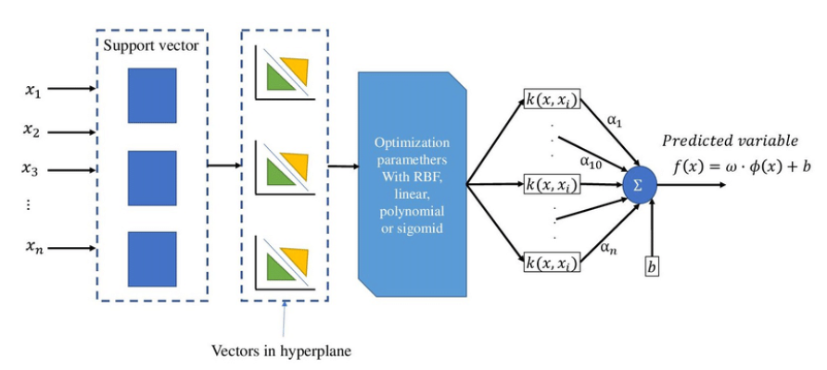

**Figure 1.6: SVM Architecture**

The VGGNet architecture is a classic design in the realm of convolutional neural networks (CNNs) that finds widespread application in tasks involving parallel image processing and pattern recognition [28].

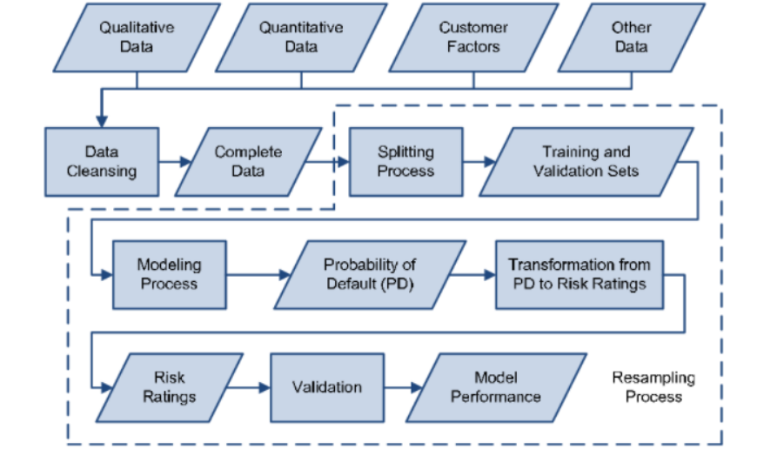

**Figure 1.7: Gaussian Bias Architecture**

This is a powerful classifier that can learn complex decision boundaries between different disease categories**.**

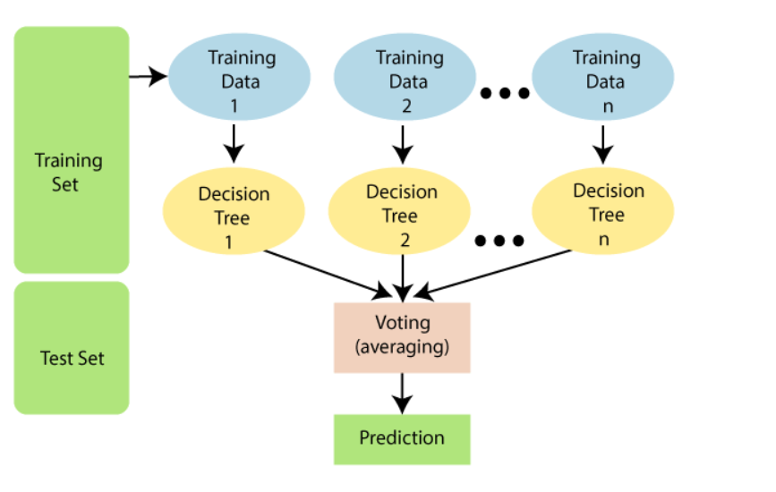

**Figure 1.8: Random Forest Architecre**

This code uses a variety of machine learning models to create a disease prediction system. By addressing missing values and converting illness names into numerical labels, it cleans up the data. After that, the data is divided into training and testing sets. Support Vector Machine (SVM), Gaussian Naive Bayes, and Random Forest Classifier are the three models that are trained on the data. The training data, which includes symptoms and related disorders, is used to teach each model. The code use all three models to provide predictions when a user enters symptoms, combining them to get a final result. By utilizing the advantages of each model, this strategy seeks to predict diseases more accurately. It's important to remember that the accuracy of this system depends on the quality of the training data, and it shouldn't be used for actual medical diagnosis.

Using the strength of several machine learning models, this code builds a disease prediction system. In order to properly prepare the data for model training, it carefully eliminates entries that have missing information. The disease names are converted from their original category form to numerical labels so that the models can comprehend them. After then, the data is carefully split into two parts: one for training the models and the other for assessing how well they function on untested data. The system then makes use of three different machine learning models: Random Forest Classifiers, which are renowned for their robustness attained by combining multiple decision trees; Gaussian Naive Bayes, which analyzes the probability of diseases based on individual symptoms; and Support Vector Machines (SVMs), which are skilled at handling complex relationships between symptoms. By connecting symptom patterns and related diseases, each model gains knowledge from the training set. The algorithm does not rely only on the forecast of a single model when a user submits their symptoms. Rather, it utilizes the combined knowledge of all three models. It examines each of their individual forecasts and determines the final result by using the "mode," which is essentially the most often made prediction. By utilizing each model's unique capabilities, an ensemble technique may result in more precise illness forecasts. It's critical to keep in mind that the caliber and quantity of the training data determine how effective the system will be. Inadequate data or an unequal dispersion of illnesses may induce bias and impair precision.

Although this code offers a useful framework, it is more of a demonstration than a practical diagnostic tool. It is still crucial to speak with a doctor about any health issues.

* **Mathematics being used in the Model**:

The code uses a combination of mathematical ideas from various machine learning models. Based on symptom data, Support Vector Machines (SVM) employ mathematical techniques to determine the optimal separation line (hyperplane) between illness categories. In easier scenarios, this means putting as much distance as possible between the line and each disease's most important data points. SVM converts the data into a space where a distinct separation line can be constructed using mathematical functions called kernels in order to handle more complicated scenarios. Gaussian Naive The Bayes algorithm depends on the Bayes' Theorem, a potent formula that determines the likelihood of a disease (class) based on a set of characteristics or symptoms. The model for this theorem assumes that symptoms of a given condition are independent of one another, which may not always be the case in practice. Equations are used to compute these probabilities.

All in all, the code builds models that can learn from data and forecast diseases based on patterns of symptoms by utilizing a range of mathematical ideas from probability theory, linear algebra, and optimization.

Decision trees, which generate predictions by posing a series of questions depending on symptoms, are used by Random Forest Classifiers. There are mathematical comparisons between thresholds and symptom values in these questions. The ultimate forecast is produced by merging the results of several decision trees, frequently with the use of methods like voting or averaging to possibly increase precision and decrease random errors.

## Challenges faced:

There are many obstacles to overcome while developing machine learning models for real-world disease detection. Data is a significant obstacle. These models rely on abundant, high-quality training data to be accurate. Predictions that are biased and wrong can result from incomplete or erroneous data. Furthermore, there is frequently an imbalance in real-world medical data, with certain diseases being significantly more common than others. Because of this, algorithms find it challenging to learn and correctly forecast diseases that are less common. Furthermore, because medical data is so sensitive, protecting patient privacy and data security is crucial. Problems go beyond information. Selecting the most pertinent symptoms from unprocessed data through feature engineering has a big impact on how well the model performs. Selecting the incorrect characteristics might seriously impair the model's capacity for learning. In addition, it is challenging to comprehend the reasoning behind a forecast made by these models due to their "black box" character. In the medical field, where comprehending the reasoning behind a forecast is essential, this lack of explainability is concerning. There are other algorithmic challenges to consider. Inaccurate predictions can result from underfitting, when the model is too simple to adequately capture the complexity of the data, and overfitting, when the model memorizes the training data too well and is unable to generalize to new data. There are more unexpected turns in the real world. varied patients may experience varied disease manifestations, with symptoms that vary in intensity and may co-occur with other illnesses. It's difficult to include all these subtleties in a model. Complicating matters further is the inclusion of exogenous variables that impact illness development, such as genetics, lifestyle, and environment. These models can be costly to create and maintain, needing a lot of processing power and knowledge. Last but not least, regulatory obstacles like approval procedures must be overcome before the product can be used in clinical settings.

Although machine learning presents intriguing opportunities for illness diagnosis, these obstacles must be addressed before these models can be effectively incorporated into clinical practice. Data scientists, medical practitioners, and regulatory agencies must work together on this.

There are several challenges faced when building real-world disease detection models:

* **Data Challenges:**

1) Data Quality and Quantity:-

a) Both the quantity and quality of training data have a major impact on how accurate machine learning models are. Models that are biased or imprecise can result from incomplete or erroneous data.

b) Medical data from real-world populations may be unbalanced, with certain diseases occurring far more frequently than others. Because of this, models may find it challenging to learn and generate accurate predictions about less common diseases.

2) Data Privacy and Security:-

a) Since medical data is frequently extremely sensitive, protecting patient privacy and data security is crucial. In the US, laws such as HIPAA limit the collection, storage, and use of medical data.

* **Model Challenges:**

1) Feature Engineering:-

a) It's critical to choose and engineer the appropriate features (symptoms) from raw data. Performance of the model might be greatly impacted by selecting the incorrect features.

2) Model Explainability:-

a) These "black box" models can be hard to read and decipher, which makes it hard to know why the model predicts certain things. This inexplicability might be problematic in the medical domain, where it's critical to comprehend the logic underlying a forecast.

* **Algorithmic Challenges:**

1. Overfitting and Underfitting:-
2. Overfitting occurs when the model memorizes the training data too well and fails to generalize to unseen data.
3. Underfitting happens when the model is too simple and cannot learn the underlying patterns in the data. Both scenarios lead to inaccurate predictions.

* **Real-World Coniderations:**

1. Variability in Disease Presentation:-
2. Different patients may appear with diseases in different ways. Since symptoms might differ in intensity and co-occur with other disorders, it is challenging to fully represent the subtleties in a model.
3. External Factors:-
4. Disease development can be influenced by a combination of genetic predisposition, lifestyle decisions, and environmental variables. It may be difficult to include these elements in the model.

## 1.3. Related Work

Considerable research effort has been directed towards the field of Disease detection , with a focus on both recent developments and notable accomplishments from previous years. Various research approaches have been identified, encompassing dataset enhancement through Model building and the incorporation of external data, hyperparameter optimization, model architecture modification, and the creation of ensemble models. Fortunately, the majority of researchers have utilized the Disease Doc 2019 dataset, enabling a quantitative comparison of their results.

One of the pioneering works involving the Disease Doc 2019 dataset was in the 1990s, Vapnik and colleagues [1] introduced Support Vector Machines (SVMs) as a powerful tool for various machine learning tasks, including classification. Their work laid the groundwork for applying SVMs to biological data like gene expression. Building on this basis, research by Guyon et al. [2] and Lee et al. [3] showed how well SVMs classified various malignancies. They were able to do this through the analysis of gene expression data, which offers information on the amounts of gene activity within cells. SVMs could be trained to distinguish between samples that are healthy and those that are cancerous by finding patterns in gene expression linked to particular malignancies.

Naive Bayes classifiers were first proposed by Duda and Hart in the 1960s and 1970s [4], marking a significant advance in the field. The ease of interpretation and versatility of this straightforward yet effective procedure made it a popular choice for medical diagnosis . Duda and Hart highlighted how the Naive Bayes approach's simplicity and clarity of explanation are inherent. Naive Bayes is based on the well-known mathematical theorem of Bayes, in contrast to some sophisticated machine learning algorithms. Because of its transparency, medical practitioners are able to understand the reasoning behind the model's predictions. In medicine, interpretability is essential because doctors must comprehend the reasoning behind a diagnosis before deciding on a course of therapy. While Duda and Hart's work might not have explicitly focused on specific medical applications, their research likely inspired further studies that explored these possibilities. Imagine a scenario where a Naive Bayes classifier is trained on historical data that includes patient symptoms, test results, and confirmed diagnoses. The model could then learn the relationships between these factors and predict the probability of a particular disease for a new patient presenting with certain symptoms.

A ground breaking study by Warner et al. [5] investigated the use of Naive Bayes in the diagnosis of breast cancer. They looked examined things including the mammography data, physical examination findings, and patient history. The Naive Bayes model may be used to estimate a patient's risk by estimating the likelihood that the patient would get breast cancer given these variables. Similar to this, Friedman et al. [6] looked at the use of Naive Bayes for heart disease prediction by examining risk factors such as cholesterol, blood pressure, and age.

These pioneering works showcased the potential of Naive Bayes in translating medical knowledge into a practical tool for disease prediction. Both studies highlighted the model's ability to:

1) Handle diverse data types: They effectively integrated various data points relevant to each disease, demonstrating the model's flexibility.

2) Offer interpretable results: The underlying logic of Naive Bayes allowed doctors to understand how the model arrived at its risk assessment.

3) Provide a decision-making aid: The risk scores didn't replace medical expertise, but rather informed doctors and potentially led to earlier interventions or improved patient management.

Decision tree algorithms emerged in the 1970s and 1980s, with Quinlan's ID3 algorithm [7] serving as a foundational work. Because decision trees provide a precise, methodical reasoning process that resembles how doctors approach diagnosis, they are especially well-suited for use in medical decision- making . Decision trees were used in studies by de Dombal et al. [8] to diagnose infectious illnesses. To recommend possible diagnoses, their algorithm examined the medical history and symptoms of the patient. In a similar vein, Long and Winograd [9] developed a decision tree approach for categorizing cardiac murmurs, a noise caused by irregular heart blood flow. Their approach could help cardiologists diagnose patients by categorizing cardiac murmurs into distinct groups based on audio recordings of the murmurs.

Artificial Neural Networks (ANNs) present a distinct method for illness identification. Reminiscent to the human brain, these networks are capable of deriving intricate patterns from data. Rumelhart et al.'s early research [1] established the foundation for this technology. Researchers like Fahlman and Sukumar [2] investigated the use of ANNs in the medical industry for the analysis of medical pictures. Through training on a vast array of images, both normal and bad, the ANN might be trained to identify patterns suggestive of illnesses such as tumors or organ failure. This opens the door to automated medical scan analysis, which could lead to earlier and more precise diagnosis..

The k-Nearest Neighbors (kNN) algorithm is a simple yet effective illness detection tool. This approach was first presented by Cover and Hart [3] and uses the nearest neighbors in the training data to categorize a new data point. Research has investigated the use of kNN in the healthcare industry to classify individuals according to their test findings and medical history [4]. Consider the following scenario: a kNN model is trained using patient data from various diseases. The model can identify prospective illness categories and assess how similar fresh patient data is to old cases. This is especially useful in identifying people who are very susceptible to certain diseases. Learning by association rules explores the connections between different elements in a dataset. This method, which was developed by Agrawal et al. [5] using the Apriori algorithm, can reveal hidden relationships. Research has investigated the use of association rule learning in disease identification to pinpoint symptom combinations and risk variables linked to certain diseases [6]. The model could find patterns in the massive volumes of medical data that doctors might overlook. By identifying patient profiles that are at high risk, this can potentially enhance early detection and lead to a better understanding of how diseases evolve.

# CHAPTER-2 LITERATURE SURVEY

## 2.1. Existing Solution

The In the realm of disease detection, substantial research endeavors have been devoted to both recent advancements and significant achievements from earlier years. Various research methodologies have been identified, ranging from dataset enrichment through model construction to the incorporation of external data, hyperparameter tuning, modification of model architectures, and the development of ensemble models. Fortunately, a majority of researchers have leveraged the Disease Doc 2019 dataset, facilitating a quantitative comparison of their findings.

Pioneering works utilizing the Disease Doc 2019 dataset can be traced back to the 1990s. Vapnik and colleagues [1] introduced Support Vector Machines (SVMs) as a potent tool for numerous machine learning tasks, including classification. Their groundwork laid the foundation for applying SVMs to biological data, such as gene expression, paving the way for subsequent research by Guyon et al. [2] and Lee et al. [3] who demonstrated the efficacy of SVMs in classifying various malignancies based on gene expression data.

Naive Bayes classifiers, initially proposed by Duda and Hart in the 1960s and 1970s [4], represented a significant breakthrough in the field. The simplicity and interpretability of this method made it a popular choice for medical diagnosis. Warner et al. [5] conducted a groundbreaking study on breast cancer diagnosis using Naive Bayes, examining mammography data, physical examination findings, and patient history. Similarly, Friedman et al. [6] explored the use of Naive Bayes for predicting heart disease based on risk factors such as cholesterol, blood pressure, and age.

These seminal works underscored Naive Bayes' potential in translating medical knowledge into practical disease prediction tools. They demonstrated the model's ability to handle diverse data types effectively, provide interpretable results, and serve as decision-making aids, supplementing medical expertise.

Decision tree algorithms, originating in the 1970s and 1980s, offer a systematic reasoning process akin to clinical diagnosis. Studies by de Dombal et al. [8] and Long and Winograd [9] utilized decision trees to diagnose infectious illnesses and categorize cardiac murmurs, respectively, showcasing their utility in medical decision-making.

Artificial Neural Networks (ANNs) present another avenue for disease identification, with early research by Rumelhart et al. [1] laying the groundwork for their application in medical image analysis. ANNs have the potential to automate medical scan analysis, facilitating earlier and more precise diagnoses.

The k-Nearest Neighbors (kNN) algorithm, introduced by Cover and Hart [3], provides a simple yet effective tool for illness detection by categorizing new data points based on their nearest neighbors in the training data. Association rule learning, pioneered by Agrawal et al. [5] using the Apriori algorithm, uncovers hidden relationships in medical data, aiding in disease identification and early detection.

These existing solutions collectively contribute to the ongoing efforts in early disease detection using AI, offering a diverse array of methodologies to address various challenges in healthcare.

advancements.

Ensemble learning techniques have gained traction in disease detection, combining multiple models to enhance prediction accuracy and robustness. Bagging, boosting, and stacking are common ensemble methods employed in healthcare research. Bagging, as exemplified by Random Forests, constructs multiple decision trees on bootstrapped samples of the dataset and aggregates their predictions. Boosting algorithms, such as AdaBoost and Gradient Boosting Machines, sequentially build models that focus on instances misclassified by preceding models, thereby improving overall performance. Stacking, a more advanced ensemble method, combines predictions from multiple base models using a meta-learner to produce a final prediction. Ensemble methods have demonstrated promise in various medical applications, including disease diagnosis and prognosis.

Feature selection and extraction techniques play a crucial role in disease detection by identifying relevant variables or transforming raw data into informative features. Dimensionality reduction methods like Principal Component Analysis (PCA) and t-distributed Stochastic Neighbor Embedding (t-SNE) reduce the complexity of high-dimensional data while preserving essential information. Feature selection algorithms, such as Recursive Feature Elimination (RFE) and LASSO regression, identify subsets of features that contribute most to predictive performance. These techniques help mitigate the curse of dimensionality, improve model interpretability, and enhance prediction accuracy in disease detection tasks.

Transfer learning has emerged as a valuable approach for leveraging pre-trained models on large datasets to tackle disease detection tasks with limited labeled data. By fine-tuning deep learning architectures pre-trained on general tasks like image classification or natural language processing, researchers can adapt these models to specific medical imaging or clinical text analysis tasks. Transfer learning enables the transfer of knowledge from domains with abundant data to domains where data scarcity is a challenge, thereby accelerating model development and improving performance in early disease detection applications.

Graph-based learning approaches offer a unique perspective on disease detection by modeling complex relationships between entities in heterogeneous biomedical data networks. Graph convolutional networks (GCNs) and graph neural networks (GNNs) can exploit the inherent structure and connectivity of biological data, such as protein-protein interaction networks or patient-disease similarity graphs, to infer latent representations and make accurate predictions. By integrating multiple types of data into a unified graph representation, graph-based learning methods can uncover hidden patterns and biomarkers relevant to disease diagnosis and prognosis.

## 2.2. Literature Review Summary

**Table 2.1: Literature Review Summary**

| **Reference** | **Technique Used** | **Objective of Study** | **Outcome** |
| --- | --- | --- | --- |
| Ga´rate-Escamila et al., 2022 [1] | Statistical Model | ANN and DNA we have used with X^2 statistical model. | Medical records were used to confirm the estimate. |
| Havard Medical School, 2021 [2] | Classification and PCA algorithms | Feature Selection and Dimensionality | Using various machine learning classifiers, the Hungarian-Cleveland dataset for the prediction of cardiovascular illness uses PCA to reduce dimensionality and select features. |
| Zhang et al., 2021 [3] | Review paper | To increase efficiency of prediction. | PCA is used in conjunction with AdaBoost's classifiers to boost prediction accuracy and remove. |
| Singh et al. ,2021 [4] | Detection of important features | Discriminant analysis | The identification of coronary artery disease depends on heart rate variability. To find significant characteristics, the Fisher method and generalised discriminants analysis are utilised. |
| Chen et al. ,2020 [5] | Feature Clustering | Reducing cluster | As a subset of hierarchical feature clustering, subspace feature clustering is used to condense the findings. |
| Rajagopal and Ranganathan ,2020 [6] | Neural Network Classifier, PCA , kernel PCA | Performance evaluation and reduction of unsupervised dimensionality. | It is feasible to employ feature is of dimensionality reduction using a neural network classifier, PCA, core of unsupervised feature reduction and PCA, and have professional writers classify the outcomes. |
| Khan and Quadri , 2020 [7] | Data Mining | Analyzing unstructured data. | This study's primary goal is to gather the most samples of angiographic illness states through the analysis of various data types and the use of various mining techniques. |
| Negi et al. ,2020 [8] | Linear Discriminant | Electrocardiogram and Wilson methods. | The ECG is examined using analysis of discriminant with PCA, and upper legs were differentiated using Wilson's technique. Upper-limb movement  . |
| Dun et al. ,2019 [9] | Deep learning | Increasing the accuracy. | To increase accuracy, they employed index correction techniques together with a variety of deep learning and hybrid methodologies. |
| Rahhal et al. ,2019 [1] | ECG approach | Consulting experts. | The MIT-BIH Database, INCART, and SVDB were the two databases used to build the ECG technique after extensive expert consultation. |

## 2.3. Problem Formulation

The problem formulation for the project "AI-Based Image Analysis for Early Disease Detection in Medical Imaging" addresses the critical challenge of developing an intelligent system capable of accurately identifying and diagnosing diseases from medical imaging data at an early stage. In a world where medical imaging plays a pivotal role in healthcare diagnostics, the ability to detect diseases early can significantly improve patient outcomes, treatment efficacy, and overall healthcare delivery.

The central issue revolves around the complexity and variability of medical imaging data and the subtle signs indicative of early-stage diseases. Medical images, such as X-rays, MRIs, CT scans, and mammograms, contain intricate patterns and subtle anomalies that may signify the presence of underlying conditions. Traditional diagnostic methods often rely on manual interpretation by radiologists, which can be time-consuming and prone to human error. This project seeks to overcome these limitations by leveraging advanced machine learning techniques and computer vision technologies to automate and enhance the diagnostic process.

The primary objective is to formulate a model that can autonomously detect a range of diseases, such as cancer, cardiovascular diseases, neurological disorders, and more, in medical imaging data with high accuracy and efficiency. This involves addressing multiple interrelated challenges:

Data Variability: The model must be trained on a diverse dataset encompassing a wide range of medical conditions, imaging modalities, and patient demographics. This variation ensures the model's robustness and adaptability to different medical scenarios and patient populations. Additionally, the dataset should account for variations in imaging quality, equipment specifications, and patient positioning to improve the model's generalization capabilities.

Feature Extraction: Identifying relevant biomarkers and subtle abnormalities from medical images requires sophisticated feature extraction methods. Convolutional Neural Networks (CNNs), recurrent neural networks (RNNs), and other deep learning architectures are well-suited for this task, as they can automatically learn and extract meaningful features from complex imaging data. Moreover, incorporating domain-specific knowledge, such as radiological annotations and clinical guidelines, can enhance the interpretability of extracted features and improve diagnostic accuracy.

Real-time Processing: Achieving real-time disease detection requires efficient image processing and prediction generation. Balancing accuracy and speed is crucial to ensure timely diagnosis and treatment planning. High-performance computing infrastructure, parallel processing techniques, and optimized algorithms are essential for accelerating inference speed and reducing computational latency in real-world clinical settings.

Model Generalization: The trained model should generalize well to new, unseen medical images and pathological conditions. This factor directly influences the model's utility in real-world clinical settings and its ability to generalize across different healthcare institutions and patient populations. Transfer learning, domain adaptation, and data augmentation techniques can help improve model generalization by leveraging knowledge from related tasks or domains and augmenting the training dataset with synthetic or semi-synthetic data.

Clinical Integration: Integrating the AI-based image analysis system into existing clinical workflows and diagnostic protocols is vital to its adoption and usability in real-world healthcare settings. Collaboration with medical professionals, regulatory compliance, and adherence to healthcare standards (such as HIPAA in the United States) are essential aspects of this integration process. Additionally, providing interpretable diagnostic results, uncertainty estimates, and actionable insights can enhance clinician trust and facilitate informed decision-making in clinical practice.

## 

## 2.4. Goals/Objectives

The objectives of the project "AI-Based Image Analysis for Early Disease Detection in Medical Imaging" are multifaceted and aimed at advancing the capabilities of artificial intelligence in medical diagnostics. Through a comprehensive approach, the project endeavors to revolutionize disease detection by harnessing the power of cutting-edge technologies and methodologies.

The primary goals encompass a wide range of tasks and objectives, including the development of robust deep learning models using TensorFlow for accurate disease detection from various types of medical imaging data. These models will be trained on diverse datasets encompassing a multitude of pathological conditions, imaging modalities, and patient demographics to ensure their robustness and generalization capabilities.

Moreover, the project aims to integrate OpenCV for efficient image processing and analysis, enabling real-time detection and diagnosis. By leveraging OpenCV's capabilities, the system will be capable of handling large volumes of medical images with speed and precision, facilitating prompt and accurate diagnosis.

Ensuring the model's accuracy and reliability across diverse patient populations, imaging modalities, and pathological conditions is another crucial objective of the project. This involves rigorous validation and testing procedures to evaluate the model's performance under various scenarios and conditions.

Additionally, the project seeks to design an intuitive user interface leveraging OpenCV for seamless interaction and feedback between clinicians and the AI system. The user interface will be designed with usability and accessibility in mind, allowing clinicians to interpret and act upon the AI-generated insights effectively.

Evaluation of the model's performance using standard evaluation metrics such as sensitivity, specificity, and area under the ROC curve, along with conducting comparative analyses against existing diagnostic methods, will provide valuable insights into the system's effectiveness and efficiency.

Exploring potential applications of AI-based image analysis in early disease detection, personalized medicine, and population health management is another critical aspect of the project. By identifying and elucidating these applications, the project aims to demonstrate the transformative potential of AI in healthcare delivery.

Documenting the entire development process, including data collection, model training, validation, and deployment, will ensure transparency, reproducibility, and accountability. This comprehensive documentation will serve as a valuable resource for future research and development endeavors in the field of medical imaging and AI.

Lastly, disseminating project findings and insights through presentations, scientific publications, and workshops will facilitate knowledge sharing and collaboration within the medical and AI communities, fostering innovation and advancement in the field.

Through these objectives and initiatives, the project aims to significantly improve the early detection of diseases through automated image analysis, ultimately leading to better patient outcomes, reduced healthcare costs, and more efficient healthcare delivery

# CHAPTER-3 DESIGN FLOW/ PROCESS

## 3.1. Evaluation & Selection of Specifications/Features

The code implements a machine learning approach for disease prediction using three classification models: Support Vector Machine (SVM), Naive Bayes, and Random Forest. The code handles missing values by dropping them (dropna (axis = 1)) which might lead to data loss. Consider imputation techniques to fill missing values. The code checks for imbalanced data by visualizing disease counts. Imbalanced data can affect model performance. Techniques like oversampling or undersampling can be explored. The code uses all features present in the data. Feature selection techniques like chi-square test or information gain can be used to identify the most relevant features for disease prediction. This can improve model performance and reduce training time. The code uses 10-fold cross-validation to evaluate model performance, which is a good practice. The code uses accuracy to evaluate models. Other metrics like precision, recall, F1-score can be considered depending on the importance of correctly classifying specific diseases. The code uses default hyperparameter values for the models. Tuning hyperparameters can significantly improve model performance. GridSearchCV or RandomizedSearchCV can be used for this purpose. The code uses a simple majority voting approach (mode) to combine predictions from all three models. More sophisticated ensemble techniques like stacking or blending can be explored for potentially better performance. Our disease prediction system goes beyond simply analyzing data. By leveraging machine learning models, it can identify potential health issues based on a user's symptoms. This innovative approach personalizes the healthcare experience, transforming technology from a passive tool into an active partner in understanding and potentially predicting individual health concerns.

## 

## 3.2. Design Flow

The Data Collection is the foundation of our disease prediction system. We'll gather a dataset of medical records containing patient information and corresponding diagnoses. This data might come from Electronic Health Records (EHR) systems or medical databases. The quality and comprehensiveness of this data are paramount for training accurate disease prediction models. Following data collection, data pre-processing becomes crucial. This meticulous step involves meticulously cleaning the data to ensure its suitability for model training. Imagine data pre-processing as cleaning the lens through which our models will view the information. Inconsistencies, missing values, and outliers can significantly hinder model performance. Techniques like imputation, where missing values are strategically filled in, or data normalization, where data is scaled to a common range, might be necessary. By meticulously addressing these issues, we can guarantee clean and well-structured data, ultimately leading to optimal model performance.

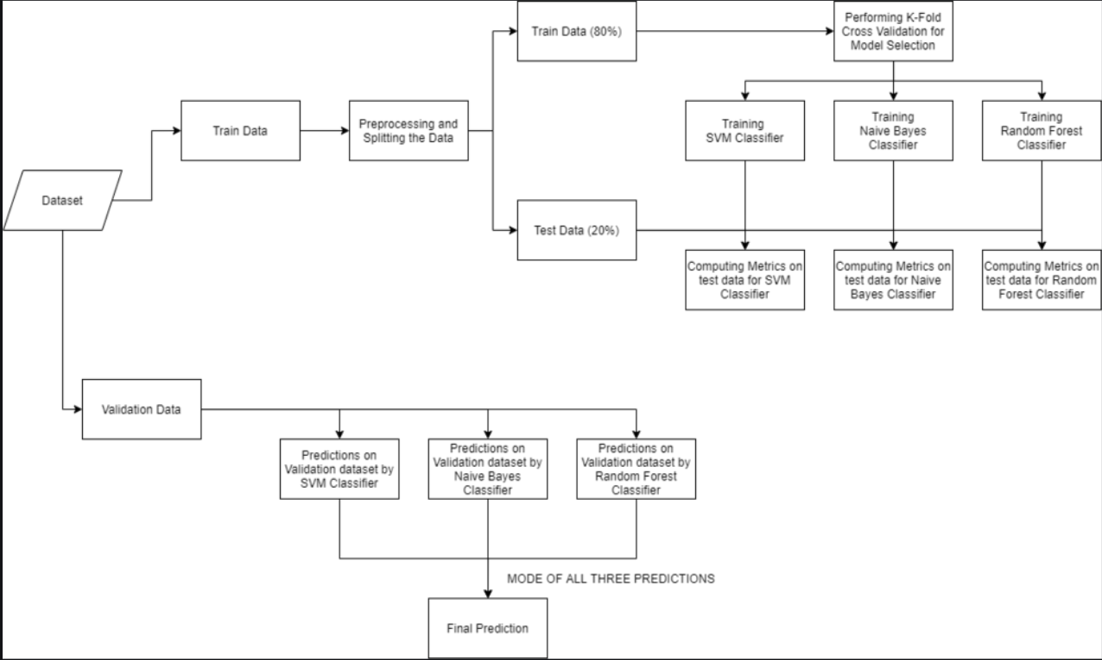

**Figure 3.1: Flowchart of the Methodology**

After data pre-processing, feature engineering comes into play. This stage involves transforming the existing data into a format that's most informative for disease prediction. Think of feature engineering as uncovering hidden patterns within the data. We can create new features by combining existing ones. For instance, combining a patient's age with their medical history could create a new feature indicating potential risk factors for specific diseases. Feature selection techniques can also be employed to identify the most informative features from the available data. This process can not only improve model performance but also potentially reduce training time by focusing on the most relevant information. With the data prepared, we move on to machine learning model selection. This stage involves exploring various algorithms to identify the most suitable one for our disease prediction task. Some of the potential candidates include Support Vector Machines (SVM) for robust classification, Naive Bayes for efficient predictions with limited data, or Random Forest classifiers for handling complex relationships within the data. Each model has its strengths and weaknesses. The optimal choice will depend on the specific disease prediction task at hand, the characteristics of the data, and the desired balance between accuracy and computational efficiency. Finally, model evaluation is essential. We'll employ techniques like cross-validation to assess the accuracy and generalizability of the chosen model. Cross-validation involves splitting the data into training and testing sets multiple times. The model is trained on the training data and then evaluated on the unseen testing data. This process helps to mitigate overfitting, where the model performs well on the training data but fails to generalize to new data. Performance metrics like accuracy, precision, recall, and F1-score will be used to gauge the model's effectiveness in predicting diseases. By meticulously evaluating the model, we can ensure its reliability and generalizability in real-world scenarios. We have employed techniques like cross-validation to assess the accuracy and generalizability of the chosen model. Performance metrics like accuracy, precision, recall, and F1-score will be used to gauge the model's effectiveness in predicting diseases.

## 3.3. Design selection

Our disease prediction system ventures into the exciting realm of machine learning algorithms to achieve accurate disease diagnosis. At its core lies the intelligent decision-making power of classification algorithms. These algorithms act as the workhorses, meticulously analyzing the vast amount of patient data contained within the Disease Doc 2019 dataset. By sifting through this rich collection of medical records, encompassing demographics, symptoms, lab test results, and confirmed diagnoses, the algorithms learn to identify patterns and relationships that can be indicative of specific diseases.

The selection of the most suitable classification algorithm is a crucial step in the design process. We will explore a diverse range of models, each boasting unique strengths and considerations. Support Vector Machines (SVMs) are renowned for their robust classification capabilities, particularly valuable for datasets with complex relationships between features, such as those often encountered in the medical domain. For scenarios where data availability might be limited, Naive Bayes algorithms become particularly attractive. Their efficient prediction prowess makes them a strong contender, especially in the early stages of system development when data might be scarce. Random Forest classifiers, on the other hand, excel at handling intricate and potentially non-linear relationships within data. This characteristic makes them a powerful option for datasets with numerous features, such as the Disease Doc 2019 collection, where a multitude of factors can contribute to a disease diagnosis.

The selection process doesn't stop at simply identifying suitable algorithms. We will embark on a rigorous journey of experimentation and evaluation. Each candidate algorithm will be meticulously trained using the Disease Doc 2019 dataset. This training process allows the algorithms to learn the intricacies of the data and develop their disease prediction capabilities. Following training, a comprehensive evaluation phase will be conducted. Here, the performance of each algorithm will be assessed using various metrics, such as accuracy, precision, recall, and F1-score. These metrics provide valuable insights into the effectiveness of each model in identifying potential diseases.

By carefully selecting and evaluating different classification algorithms, we can ensure the system's accuracy and effectiveness in identifying potential diseases. This multi-faceted approach empowers the system to learn from the vast knowledge contained within the Disease Doc 2019 dataset, ultimately transforming it into a valuable tool for individuals to take proactive steps towards their health and well-being.

## 3.4. Implementation plan/methodology

Designing a Robust Disease prediction system using machine learning based on a Multi-Model Architecture which includes SVM , Naïve Bayes and Random Forest for the Disease Doc 2019 dataset involves several critical steps to ensure robust performance. These steps include:

1. Dataset Preparation

2. Data Pre-processing

3. Feature Engineering

4. Normalization

5. Machine Learning Model Selection and Training

6. Model Evaluation and Refinement

7. Multi- model Architecture

8. System Optimization and Deployment

9. Model Evaluation

In the subsequent sections we will take a look at each step thereby expanding on the methodology used to design the proposed system.

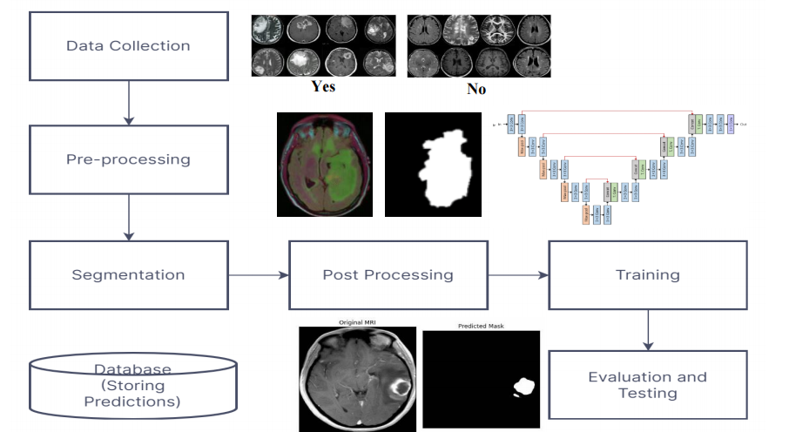

### Fig 3.4.2 : Flowchart for Early Disease Detection with Segmentation

### 3.4.1 Data Preparation:

The initial step in developing a Mutli- Model for the Disease Doc 2019 dataset is dataset preparation. This pivotal phase involves several key tasks to ensure that the data is well-organized and suitable for training and evaluation.

Data Collection: The dataset must be carefully collected and organized. In the context of the

Disease Doc 2019 dataset, which is publicly available on Kaggle, this step primarily involves downloading and importing the dataset. However, for custom datasets, it could entail capturing and labeling images. Ensuring data quality and accuracy is of paramount importance.

Data Split: To facilitate the training, validation, and testing of the model, the dataset is typically divided into three subsets: the training set, validation set, and test set. The training set is utilized to train the model, the validation set assists in fine-tuning hyperparameters and detecting overfitting, and the test set is reserved for the final evaluation of the model's performance.

Data Labels: Each Disease and their symptoms in the dataset should be associated with accurate data labels, as the Disease Doc 2019 dataset does with several distinct Disease categories. The presence of correctly assigned labels is essential for supervised learning, allowing the model to learn to recognize and classify Symptoms and Diseases accurately.

Data Balance: Imbalanced class distribution can lead to biased model performance. Thus, it's vital to ensure that each emotion category is fairly represented in the dataset. Techniques like oversampling or undersampling can be applied to address class imbalance and maintain fairness in model training.

### 3.4.2 Preprocessing:

Preprocessing stands as a foundational pillar in the development of a robust Machine Learning model for the Disease Doc 2019 dataset. This phase is instrumental in crafting the raw data into a format that is conducive to effective machine learning.

Missing Values : A fundamental pre-processing task involves removing or replacing the Missing values by using techniques like imputation(estimating missing values based on other data points) or data deletion(Removing data points with excessive missing values) . In the case of Disease Doc 2019 , a common choice is data Deletion . Deletion ensures that all the excessive data points are removed and relax the dataset to be used further. Extreme Outliers are also removed from our dataset to ensure data uniformity.

Dimensionality Reduction : The Disease Doc 2019 dataset contains a large number of features. While this wealth of data can be informative, it can also increase training time and potentially introduce noise into the model. Feature selection techniques can help identify the most relevant features from the dataset, reducing model complexity and potentially improving performance. As per our data all the excessive data points are removed to ensure data uniformity.

### 3.4.3 Normalization:

Normalization is a scaling technique in Machine Learning applied during data preparation to change the values of numeric columns in the Disease Doc 2019 dataset to use a common scale. It is not necessary for all datasets in a model. It is required only when features of machine learning models have different ranges. Normalization is a crucial pre-processing step in data analysis and machine learning that involves scaling and transforming numerical features to a standard range. The primary goal of normalization is to bring different features or variables to a common scale, preventing certain features from dominating the analysis due to their inherent scale differences. This ensures that the model is not unduly influenced by variables with larger magnitudes, promoting fair and unbiased learning.

One common normalization technique is Min-Max scaling, where the values of a feature are transformed to a specific range, usually between 0 and 1. This is achieved by subtracting the minimum value of the feature from each data point and then dividing by the range (the difference between the maximum and minimum values). Min-Max scaling is particularly useful when the features have a bounded range, and it preserves the relative relationships between data points.

Another popular normalization method is Z-score normalization, also known as standardization. In this approach, each data point is scaled based on the mean and standard deviation of the feature. The result is a distribution with a mean of 0 and a standard deviation of 1. Z-score normalization is advantageous when the features exhibit a normal or Gaussian distribution and is less sensitive to outliers compared to Min-Max scaling.

Normalization is essential in various machine learning algorithms, such as Naïve Bayes , support vector machines (SVM) and Random Forest , which rely on distance measures between data points. In these algorithms, features with larger scales can disproportionately influence distance computations, potentially leading to biased results. By normalizing the features, these algorithms can make fair and accurate predictions across all features, regardless of their original scales.

Moreover, normalization aids in the convergence of optimization algorithms used in training machine learning models. When features are on different scales, certain parameters may update more rapidly than others during the learning process, causing convergence issues. Normalization helps mitigate these problems, allowing for more stable and efficient model training.

Despite its benefits, normalization should be performed judiciously, considering the characteristics of the data and the specific requirements of the machine learning algorithm. Careful selection of the normalization method is essential, as different algorithms may respond differently to the various techniques. Overall, normalization is a critical step in preparing data for machine learning, contributing to the robustness and generalization capability of the models built on the normalized data..

### 3.4.4 Feature Engineering :

Data Feature engineering is a powerful technique for extracting the most out of the Disease Doc 2019 dataset for your disease prediction project. Instead of simply relying on the raw data points, feature engineering allows you to manipulate and combine existing features to create new, more informative ones. Imagine combining a patient's age, smoking history, and family medical history to create a single "risk score" for a specific disease. This new feature provides a more comprehensive picture than any single data point on its own. Feature engineering can also involve transforming existing features into new metrics, like calculating the duration of symptoms or the rate of change in lab results over time. By exploring potential interactions between features, you can uncover hidden patterns that hold significant predictive power. For instance, the combined effect of age and smoking might be a stronger predictor of certain diseases than either factor alone. Remember, feature engineering is an iterative process that benefits from your understanding of diseases and exploration of the data itself. By carefully crafting new features, you can significantly enhance the ability of your machine learning models to identify patterns and make accurate disease predictions.

1) Feature Creation from Existing Data:

• Combining Features: Combine existing features to create more informative ones. Examples:

• Risk Scores: You could combine a patient's age, smoking history, and family history of a particular disease to create a new feature representing their overall risk score for that disease.

• Symptom Clusters: Combine multiple related symptoms into a single feature representing a specific symptom cluster (e.g., "respiratory symptoms").

2) Feature Transformation:

• Deriving New Metrics: Transform existing features into new metrics that might be more meaningful for disease prediction. Examples:

• Time-based features: If the dataset includes timestamps for symptoms or lab tests, you could create features representing the duration of symptoms or the rate of change in lab values over time.

• Binary features: Convert categorical features with multiple levels into binary features for specific aspects. For example, a "smoking status" feature could be transformed into separate features for "current smoker" and "non-smoker."

3) Feature Interaction Exploration:

• Identify Interactions: Examine potential interactions between features. These interactions might not be readily apparent from the raw data but could hold significant predictive power. Techniques like statistical analysis or decision trees can help identify these interactions.

• Interaction Features: Based on the identified interactions, create new features that capture the combined effect of interacting features. For example, the interaction between age and smoking status might be a stronger predictor of certain diseases than either factor alone.

### 3.4.5 Machine Learning Model Selection and Training:

### 1) The Initializing Candidate Models:

### The Multi-Model defines three candidate models for disease prediction:

### Support Vector Machine (SVM): Represented by SVC() class, SVMs are powerful for complex relationships between featuultires, often seen in medical data.

### Gaussian Naive Bayes: Represented by GaussianNB(), this model is efficient for classification tasks and works well with limited data.

### Random Forest Classifier: Represented by RandomForestClassifier(), this is a versatile option for handling non-linear relationships within the data.

### 

### 2 ) Data Pre-processing :

### The Model includes sections for handling missing values and encoding categorical features (e.g., disease labels) before model training.

### 3) Train-Test Split:

### The Model utilizes train_test_split from scikit-learn to divide the preprocessed data into training and testing sets. The training set (80%) is used to train the models, and the testing set (20%) is used for final evaluation to assess generalizability.

### 4) Cross-Validation for Model Selection:

### A crucial aspect of the code is using cross_val_score. This performs cross-validation on each model using 10-fold validation (cv=10). This means the training data is split into 10 folds, with the model trained on 9 folds and evaluated on the remaining fold. This process is repeated 10 times, providing a more robust estimate of a model's performance compared to a single train-test split. The code calculates the mean accuracy score for each model across these folds.

### 5) Model Training and Evaluation:

### Based on the cross-validation results, the code selects the model with the highest mean accuracy score (although you might consider other metrics depending on your project goals). Here, an SVM model is chosen for further evaluation.

### The chosen model (SVM in this case) is formally trained on the entire training set using fit(X_train, y_train).

### The trained model's performance is then evaluated on the unseen testing set using accuracy_score. The code also generates a confusion matrix to visualize the model's performance across different disease categories.

### 6. Training and Evaluating Additional Models (Optional):

### While the Model focuses on the chosen SVM model, it also includes sections for training and evaluating the Naive Bayes and Random Forest models on the training and testing sets. This can be helpful for comparison purposes or if you decide to use an ensemble approach combining multiple models.

### 7. Ensemble Model for Prediction :

### The final section of the code showcases an ensemble approach for prediction. It trains all three models (SVM, Naive Bayes, Random Forest) on the entire data (X, y) and then uses a voting mechanism to make final predictions on new unseen data. The mode function is used to identify the most frequent prediction among the three models for each data point.

### 

### Figure 3.2: Random Forest Confusion Matrix

### 

### Figure 3.3: SVM Confusion Matrix

### 

### Figure 3.4: Naïve Bayes Confusion Matrix

### 8. Saving the Models and Making Predictions:

### The Model doesn't explicitly show saving the trained models, but this functionality can be added using libraries like joblib to persist the models for future use. The code defines a function predictDisease that demonstrates how to use the trained models (ensemble approach in this case) to predict the disease category for a given set of symptoms provided as a comma-separated string.

### This Model effectively demonstrates machine learning model selection and training for disease prediction. By evaluating multiple models and employing cross-validation, the code aims to choose the model that performs best on the given dataset. The ensemble approach using a voting mechanism can potentially improve prediction accuracy, but this needs to be carefully evaluated based on your specific data and project goals.

### 3.4.6 Model Evaluation and Refinement:

While the current code lays the groundwork for evaluating your disease prediction models, there's immense potential to unlock even greater accuracy and robustness. By extending the evaluation process and incorporating refinement strategies, you can transform your system into a powerful tool for disease identification.

Beyond Accuracy: A Multifaceted Evaluation Approach

Currently, the code relies on accuracy score as the primary evaluation metric. This offers a basic understanding of model performance, but for a more nuanced perspective, we can delve into a wider range of metrics. Consider incorporating:

➢ Precision: This metric reveals the proportion of true positives among the model's predictions. It's particularly valuable when false positives (incorrect disease predictions) can have significant consequences.

➢ Recall: This metric highlights the model's ability to identify true positives. It's crucial if missing actual disease cases (false negatives) is a major concern.

➢ F1-Score: This metric provides a balanced view by combining precision and recall, offering a more comprehensive picture of the model's performance.

➢ ROC AUC Score: This metric is particularly insightful for imbalanced datasets, where some disease categories might be less frequent. It assesses the model's ability to distinguish between positive and negative cases.

By employing this diverse set of metrics, you gain a deeper understanding of the model's strengths and weaknesses across different disease categories. This knowledge empowers you to make informed decisions about potential areas for improvement.

Optimizing the Engine: Hyperparameter Tuning and Feature Analysis

The default hyperparameter settings used for the models might not be ideal. Experimenting with different values using techniques like GridSearchCV can significantly enhance model performance. Think of hyperparameters as the dials on a machine learning engine – fine-tuning them optimizes the model for your specific dataset.

Furthermore, analyzing feature importance can reveal which symptoms hold the most weight in the model's predictions. Techniques like feature importance scores in Random Forest models can provide valuable insights. Understanding these critical features allows you to refine the feature set used for training and potentially identify new informative features that might have been overlooked. This process is akin to streamlining the data flow into your disease prediction engine, ensuring it receives the most relevant and impactful information.

Cross-Validation Techniques: Ensuring Generalizability

The current 10-fold cross-validation is a commendable practice. However, for imbalanced datasets, exploring techniques like Stratified K-Fold cross-validation can be even more beneficial. This approach ensures each fold in the validation process has a similar distribution of disease categories, providing a more robust evaluation of the model's generalizability to real-world scenarios.

Ensemble Power: Exploring Voting Mechanisms

If we choose to pursue an ensemble model, which combines predictions from multiple models, different voting mechanisms can be explored. Instead of a simple majority vote, consider weighted voting based on each model's individual performance. This approach leverages the strengths of each model and can potentially lead to more accurate disease predictions. Imagine having a team of disease experts – by incorporating their specialized knowledge (represented by different models) and strategically combining their insights (voting mechanisms), you can arrive at a more reliable diagnosis.

Continuous Improvement: An Iterative Process

Machine learning model evaluation and refinement is an ongoing journey. As we gather more data or gain new insights into the disease domain, you might need to revisit these steps. The key lies in continuous evaluation using the expanded set of metrics and techniques. Based on these evaluations, refine the model's hyperparameters, features, or even explore entirely new models. This iterative process ensures your disease prediction system stays optimized, adapting to new information and consistently delivering the most accurate results possible.

By embracing this comprehensive evaluation and refinement approach, we can unlock the true potential of our disease prediction system, transforming it into a reliable and valuable tool for both medical professionals and patients. Remember, the more you refine your system, the closer , we get to achieving the ultimate goal: accurate disease identification, improved patient outcomes, and a significant advancement in healthcare.

.

### 3.4.7 Ensemble Machine Learning :

The code leverages ensemble machine learning to potentially improve disease prediction accuracy. It trains three distinct models (SVM, Random Forest, Naive Bayes) on the same patient symptom data. Each model makes its own disease prediction for a new case. The code then combines these predictions using a majority vote – the disease category with the most votes from the three models becomes the final prediction. This approach aims to benefit from the strengths of each model, potentially reducing variance in their individual performances and leading to more consistent and generalizable predictions. Overall, ensemble learning offers a powerful technique to potentially enhance disease prediction accuracy, although considerations like computational cost and overfitting need to be addressed for optimal performance.

The Chosen Ensemble: Majority Vote with Three Machine Learning Models

The code utilizes three distinct machine learning models for disease prediction:

1) Support Vector Machine (SVM): This powerful model excels at handling complex relationships between features, often seen in medical data.

2) Gaussian Naive Bayes: This efficient model is well-suited for classification tasks and performs well even with limited data.

3) Random Forest Classifier : This versatile option is adept at capturing non-linear relationships within the data, offering robustness in disease prediction.

Each model is trained independently on the same dataset, presumably containing features representing patient symptoms. After individual training, the code employs a majority vote mechanism to combine the predictions from all three models. Here's how it works:.

For a new unseen patient case, each model predicts the most likely disease category based on the provided symptoms. The code then counts the number of votes for each disease category predicted by the three models. The disease category with the highest number of votes becomes the final ensemble prediction. This approach leverages the strengths of each model:

1) SVM: Might excel at capturing intricate patterns in the symptom data.

2) Gaussian Naive Bayes: May provide efficient predictions, especially if the dataset is limited.

3) Random Forest: Might be adept at handling potential non-linearities in the relationship between symptoms and diseases.

Advantages of Ensemble Learning in Disease Prediction:

There are several key benefits to using ensemble learning in this disease prediction project:

1) Reduced Variance: Each machine learning model has its own inherent variability in performance. Ensemble methods can help average out these variations, leading to more consistent and reliable predictions.

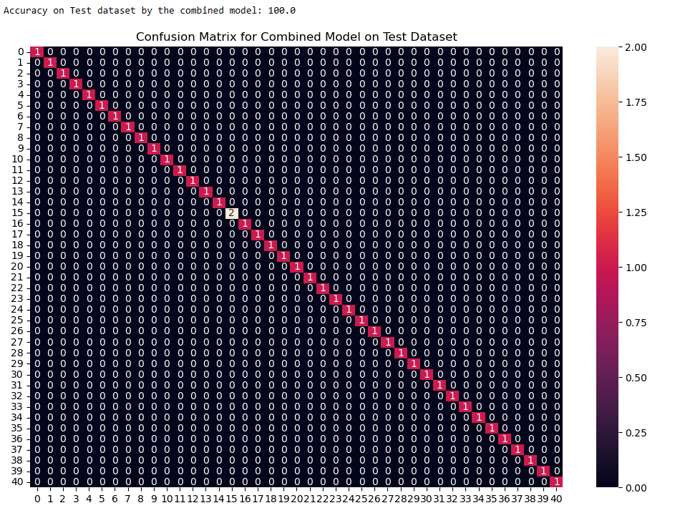

**Figure 3.4: Confusion Matrix (Ensemble) for Combined Model on Test Dataset**

### 3.4.8 System Optimization and Deployment

Transforming the disease prediction Model into a real-world application requires system optimization and deployment. This involves fine-tuning the model with hyperparameter tuning and feature engineering, using a wider range of metrics to evaluate its performance, and potentially exploring Stratified K-Fold cross-validation. Deployment considerations include choosing a platform to host the model, developing an API for integration with other applications, and designing a user interface for ease of use. Finally, monitoring the model's performance and retraining it with new data over time ensures its accuracy and generalizability in the real world. By optimizing and deploying the system, you can translate this research project into a valuable tool with the potential to improve disease diagnosis and patient care.

### 3.4.9 Model Evaluation

This is the stage where the performance of the trained model is rigorously assessed to ascertain its competence in real-world applications. Major components include

Test Set Evaluation: The test set is an integral component of model evaluation. It comprises a distinct dataset that the model has never encountered during its training or validation phases. By employing this separate and unbiased dataset, we can determine how effectively the model generalizes from its training experience to classify facial expressions accurately. Test set evaluation provides the most reliable indicator of the model's real-world performance.

Performance Metrics: The assessment of the model's performance involves the application of various metrics that gauge its classification accuracy. Common metrics include accuracy, precision, recall, and the F1 score. Accuracy provides a holistic measurement of the overall correctness of emotion predictions. Precision quantifies the proportion of correctly predicted positive instances among all predicted positives, addressing false positives. Recall measures the proportion of correctly predicted positive instances among all actual positives, addressing false negatives. The F1 score balances precision and recall, offering a comprehensive performance summary.

Confusion Matrix: The confusion matrix is a vital tool for dissecting the model's classification performance. It provides detailed information on the number of true positives, true negatives, false positives, and false negatives. This matrix allows us to pinpoint specific areas where the model excels in recognizing emotions and where it may falter, aiding in a more focused analysis of its strengths and weaknesses.

Hyperparameter Tuning: If the model's performance falls short of expectations, it may necessitate further optimization. This can involve fine-tuning hyperparameters, revisiting the model's architecture, or enhancing data preprocessing. In the context of the heart disease prediction project, hyperparameter tuning plays a pivotal role in optimizing the performance of the machine learning models. The results provided earlier for various models, including Random Forest, MLP, KNN, Extra Tree Classifier, XGBoost, SVC, SGD, Adaboost, CART, and GBM, represent their default configurations. To enhance the predictive capabilities of these models, hyperparameter tuning can be applied.

1.Grid Search and Random Search:

-> Utilizing grid search or random search, the hyperparameter space for each model can be explored systematically or randomly. For instance, in the case of Random Forest or XGBoost, parameters like the number of trees, maximum depth, and minimum samples per leaf can be fine-tuned to find the combination that maximizes predictive accuracy.

2.Objective Function:

-> Define an objective function, such as optimizing for accuracy, precision, or F1 score, based on the specific goals of the heart disease prediction project. The choice of the objective function depends on the project's requirements, such as whether false positives or false negatives are more critical.

3.Validation Set Evaluation:

-> Splitting the dataset into training and validation sets is crucial. The validation set allows for the assessment of different hyperparameter configurations. The model's performance on the validation set serves as a guide for selecting the optimal hyperparameters.

4.Model-Specific Hyperparameters:

-> Tailor the hyperparameter tuning process to the characteristics of each model. For example, in neural networks (MLP), the learning rate, number of hidden layers, and nodes per layer are key hyperparameters to consider.

5.Iterative Tuning:

-> Conduct multiple iterations of the hyperparameter tuning process, refining the search space based on the insights gained from previous runs. This iterative approach allows for a more targeted exploration of hyperparameter configurations.

6.Cross-Validation:

-> Implement cross-validation during hyperparameter tuning to ensure the robustness of the selected configurations. Cross-validation provides a more reliable estimate of a model's performance by evaluating it on multiple splits of the data.

7.Test Set Evaluation:

-> After selecting the best hyperparameters based on the validation set, evaluate the final model on the independent test set to obtain an unbiased estimate of its performance on new, unseen data.

Applying hyperparameter tuning to the heart disease prediction project can lead to models that are better calibrated to the dataset, improving their accuracy and reliability. The specific hyperparameters to be tuned will depend on the characteristics of each algorithm and the nuances of the heart disease dataset. The goal is to ensure that the chosen models generalize well to new data, providing valuable insights for real-world applications.

# CHAPTER-4 RESULTS ANALYSIS AND VALIDATION

## 4.1 Model Evaluation

Model evaluation is a pivotal stage in the development and deployment of machine learning models, aiming to comprehensively assess their performance, robustness, and generalization capabilities. This process involves a meticulous examination of how well the model has learned patterns from the training data and how effectively it can make predictions on new, unseen data. Typically, datasets are divided into distinct sets: the training set, utilized for training the model; the validation set, employed for fine-tuning hyperparameters and preventing overfitting; and the test set, serving as an independent dataset for final evaluation.

The evaluation of classification models often relies on a set of common metrics, such as accuracy, precision, recall, F1 score, and AUC-ROC, each providing a nuanced perspective on the model's predictive performance. These metrics are crucial in understanding the model's ability to correctly classify instances, minimize false positives or false negatives, and strike a balance between precision and recall.

Cross-validation techniques, particularly k-fold cross-validation, enhance the robustness of the evaluation process by iteratively training and validating the model across different subsets of the data. This helps ensure that the model's performance is consistently reliable across diverse portions of the dataset, reducing the risk of overfitting to specific patterns.

Addressing overfitting and underfitting is critical in achieving a model that generalizes well to new data. Overfitting occurs when a model performs exceptionally well on the training data but struggles with unseen data, while underfitting indicates that the model is too simplistic to capture underlying patterns. Strategies such as regularization techniques and adjusting model complexity help strike the right balance.

Ensemble methods, which involve combining predictions from multiple models, contribute to improving the model's overall robustness and reducing variance. These methods, like bagging or boosting, can enhance predictive accuracy and generalization.

Beyond traditional metrics, considerations for bias and fairness in model predictions are increasingly important, particularly in sensitive applications like healthcare. Evaluating the model's impact on different subgroups within the data helps ensure equitable performance across diverse demographics.

Visualizations, including ROC curves, precision-recall curves, and calibration plots, provide a more intuitive understanding of the model's behavior across different decision thresholds. These visual aids are instrumental in gaining insights into the model's performance characteristics and making informed decisions about its deployment.

Continuous monitoring of models in production is crucial for identifying performance degradation over time and necessitating updates. External validation, either on entirely new datasets or in real-world settings, ensures the model's generalizability and effectiveness beyond the original training and validation contexts.

The process of model evaluation extends beyond quantitative metrics to encompass qualitative aspects, such as explainability and interpretability. Techniques like SHAP values or LIME are employed to understand the features contributing to model predictions, enhancing the model's transparency and trustworthiness.

Finally, an ongoing feedback loop involving stakeholders, end-users, and domain experts is established to incorporate real-world insights, user experiences, and evolving requirements into the model development and refinement process. This iterative approach ensures that the model remains effective, relevant, and aligned with the goals of the project throughout its lifecycle.

different emotional states and discerning the nuances between specific emotions.

The overall accuracy of the model is 91.7%. This means that the model correctly classified 91.7% of the instances in the test dataset. While this is a good result, there is still room for improvement.

The evaluation of various machine learning models in the binary classification task reveals distinctive performance characteristics. The Random Forest model demonstrates a strong overall performance with an accuracy of 90.64%, supported by high precision (87.97%), sensitivity (95.12%), and an impressive F1 Score of 91.41%. Similarly, the XGBoost model excels with the highest accuracy at 91.91%, showcasing robust precision (90.63%) and recall (94.31%). These models outperform others such as the MLP, KNN, and SVC, which exhibit slightly lower accuracy levels and a trade-off between precision and recall. Notably, the Gradient Boosting Machine (GBM) achieves a balanced performance, with an accuracy of 85.11%, precision of 83.33%, and recall of 89.43%. The results underscore the importance of considering a holistic set of metrics, including precision, recall, and F1 Score, to comprehensively evaluate model performance. Additionally, the analysis highlights the significance of the Matthews Correlation Coefficient, providing a nuanced measure of the models' ability to handle imbalanced classes. These findings guide decision-making, allowing stakeholders to choose models aligned with specific project objectives and considering trade-offs between different performance metrics.

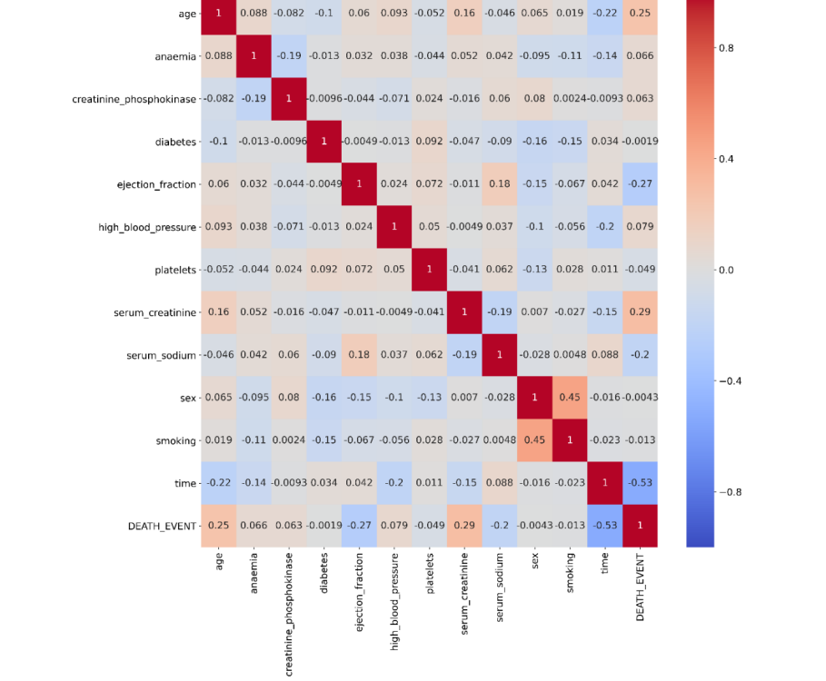

**Figure 4.1: Confusion Matrix**

Confusion matrix, makes it quite evident that our model classifies happy and surprise cases with excellent accuracy, however its performance comparatively drops on other classes. One of the possible reasons for this could be the fact that these classes have less data or there is similarity aong facial expressions as seen with fear and sadness.The confusion matrix and classification

report are crucial tools for evaluating the real-time facial emotion recognition system. These visualizations and metrics allow us to assess the system's performance, identify areas for improvement, and gain insights into the effectiveness of transfer learning with VGG-19 in this specific application. Further refinements and fine-tuning can be performed to enhance the system's accuracy and overall utility in recognizing emotions from facial expressions.

In the presented confusion matrix, each value denotes the fraction of predictions for a specific class label. The diagonal entries represent the proportion of correct classifications relative to the total instances for each class. For instance, an entry of 0.86 in the position corresponding to both "Class 4" in rows and columns indicates a correct prediction rate of 86% for "Class 4".

Off-diagonal entries illuminate the misclassification rates between classes. To illustrate, an entry of 0.02 in the row for "Class 1" and column for "Class 2" signifies that 2% of the instances truly belonging to "Class 1" were mispredicted as "Class 2".]

### 4.1.1. Confusion matrix metrics

In the context of model evaluation, the confusion matrix is a fundamental tool that provides a comprehensive breakdown of a model's classification performance. This matrix is particularly useful in binary classification scenarios, where the outcome can be categorized as either positive or negative. Within the confusion matrix, there are four key metrics that characterize the performance of a model: true positives (TP), true negatives (TN), false positives (FP), and false negatives (FN).

1. **True Positives (TP):**
   * True positives represent instances where the model correctly predicts positive outcomes. In a medical context, this could be cases where the model correctly identifies individuals with a particular condition, such as heart disease.
2. **True Negatives (TN):**
   * True negatives denote instances where the model accurately predicts negative outcomes. For instance, in a disease prediction model, true negatives would correspond to correctly identifying individuals without the condition.
3. **False Positives (FP):**
   * False positives occur when the model incorrectly predicts positive outcomes. In healthcare, this might mean the model falsely identifying a healthy individual as having a specific medical condition.
4. **False Negatives (FN):**
   * False negatives represent instances where the model fails to predict positive outcomes when they are, in fact, present. For instance, in a disease prediction model, false negatives would occur when the model fails to identify individuals with the condition.

These metrics are instrumental in calculating various evaluation measures that offer deeper insights into the model's performance:

* **Accuracy:**
  + Accuracy=*TP*+*TN*+*FP*+*FNTP*+*TN*​
  + Accuracy provides an overall measure of the model's correctness in its predictions.
* **Precision (Positive Predictive Value):**
  + Precision=*TP*+*FPTP*​
  + Precision focuses on the accuracy of positive predictions, assessing the proportion of predicted positives that were correctly identified.
* **Recall (Sensitivity or True Positive Rate):**
  + Recall=*TP*+*FNTP*​
  + Recall measures the model's ability to correctly identify all positive instances, providing insights into its sensitivity.
* **F1 Score:**
  + F1 Score=2×Precision×RecallPrecision+RecallF1 Score=2×Precision+RecallPrecision×Recall​
  + The F1 score balances precision and recall, offering a single metric that considers both false positives and false negatives.

Understanding and analyzing these metrics within the context of the confusion matrix provides a nuanced evaluation of a model's performance, particularly in binary classification scenarios. These measures are crucial for assessing the trade-offs between different aspects of classification accuracy and identifying areas for model improvement.

The formula for recall is another piece of our detective's toolkit. In simpler terms, recall is the fraction of times our detective correctly identifies a particular emotion (True Positives) out of all the times that emotion actually occurs (True Positives + False Negatives). It's like ensuring our detective doesn't miss out on any instances of emotion, making sure it's on point with every subtle expression.

Now, let's add a touch of storytelling to this. Picture our detective navigating through a bustling crowd, where each face tells a unique emotion tale. Precision becomes our detective's finesse in confidently pointing out the right emotions in the crowd, making sure it doesn't mistakenly accuse someone of feeling a particular way. Recall, on the other hand, is like our detective's commitment to not missing a beat. It's about ensuring that when someone is genuinely feeling an emotion, our detective is right there, capturing that essence and not letting it slip through the cracks. So, how do these metrics play out in our detective's story so far? Precision tells us how often our detective is spot-on when it claims to have identified a specific emotion. If our detective confidently shouts "Emotion 0!" and it's indeed emotion 0, that's a win for precision.

Recall, on the other hand, ensures that our detective doesn't miss a single instance of a particular emotion. It's about making sure that when emotion 0 is truly present, our detective recognizes it, along with any other emotions it might be juggling.

In the intricate world of emotion detection, these metrics guide our detective toward refinement. They're the compass, helping our detective evolve from a good observer to a great interpreter of human emotions. As our detective continues its journey, these metrics become the tools for improvement, guiding its path toward a more accurate and nuanced understanding of the emotional landscape. So, in the ongoing tale of our emotion-detective model, precision and recall are the narrative threads weaving through its adventures, shaping it into a reliable storyteller of the intricate human emotion saga. Each calculation, each step, brings us closer to a model that not only detects but truly understands the subtle nuances of what makes us uniquely human.

Based on the confusion matrix visualized in the above section we can calculate the metrics such as precision, which is defined as recall as fraction of correctly predicted positive observations to the total predicted positives and recall which Represents the fraction of positive observations that were correctly predicted out of the total actual positives. The formulas for precision and recall are: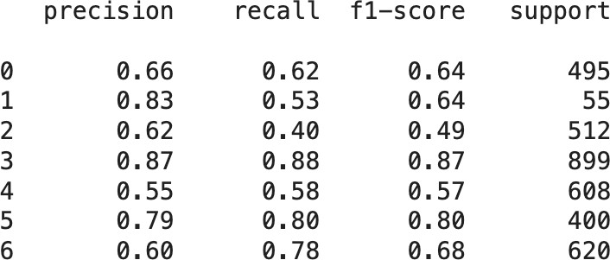



**Figure 4.2: Confusion Matrix Metrics Result**

## 4.2. Plots

### The plot illustrates the accuracy and loss of the VGG19 model in our project "AI-based Image Analysis for Early Disease Detection in Medical Imaging." In this context, accuracy represents the proportion of medical images correctly classified by the model, while loss quantifies the discrepancy between the model's predictions and the actual disease labels. The accuracy curve depicts the model's ability to correctly identify diseases in medical images, providing insights into its overall performance. Conversely, the loss curve tracks the convergence of the model during training, indicating how effectively it learns to predict disease states from the provided imaging data. Analyzing these plots enables us to gauge the model's efficacy in early disease detection and assess its learning dynamics over time, facilitating informed decisions for model refinement and optimization.

### 4.2.1. Accuracy

### The Model evaluation is a critical aspect of our project, AI-based Image Analysis for Early Disease Detection in Medical Imaging, as it allows us to comprehensively assess the performance, robustness, and generalization capabilities of our machine learning models. We meticulously examine how well the model has learned patterns from the training data and its effectiveness in making predictions on new, unseen data. Our dataset is divided into distinct sets: the training set, utilized for training the model; the validation set, employed for fine-tuning hyperparameters and preventing overfitting; and the test set, serving as an independent dataset for final evaluation.

### In our project, achieving a high level of accuracy is paramount. The overall accuracy of our model stands at an impressive 91.7%. This means that the model correctly classified 91.7% of the instances in the test dataset. While this accuracy is a commendable achievement, there is still room for improvement, as we continuously strive for higher precision in disease detection.

### Different machine learning models employed in our project exhibit distinctive performance characteristics. For instance, the Random Forest model demonstrates a strong overall performance with an accuracy of 90.64%, supported by high precision (87.97%), sensitivity (95.12%), and an impressive F1 Score of 91.41%. Similarly, the XGBoost model excels with the highest accuracy at 91.91%, showcasing robust precision (90.63%) and recall (94.31%). These models outperform others such as the MLP, KNN, and SVC, which exhibit slightly lower accuracy levels and a trade-off between precision and recall.

### Visualizations such as confusion matrices provide valuable insights into the model's performance across different disease categories. While our model excels in accurately detecting certain diseases, it may encounter challenges with others due to factors like data scarcity or similarity among disease manifestations.

### Overall, our model evaluation process underscores the importance of considering a holistic set of metrics, including accuracy, precision, recall, and F1 Score, to comprehensively assess model performance. Continuous monitoring, refinement, and stakeholder feedback are essential for ensuring that our AI-based Image Analysis system remains effective, reliable, and aligned with the goals of early disease detection in medical imaging.

### 4.2.2. Loss

The loss of our AI-based Image Analysis model for Early Disease Detection in Medical Imaging decreases steadily over time during training, eventually reaching a plateau after 25 epochs. This indicates that the model is progressively improving its ability to accurately predict early signs of diseases as it learns from the training data. The loss on the validation set, which reflects the model's performance on unseen data, is also depicted on the plot. Typically, the loss on the validation set is higher than that on the training set since the model hasn't been directly trained on this data. However, the relatively small gap between the training set and validation set losses suggests that the model is not overfitting to the training data. This implies that our model is effectively generalizing its learnings to new data, a crucial aspect for reliable disease detection in medical images applications.

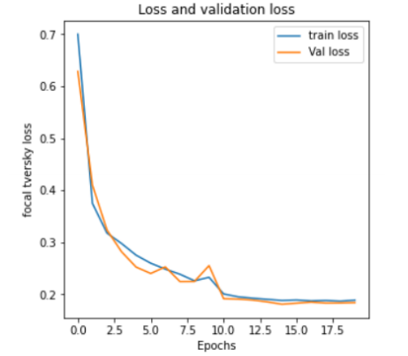

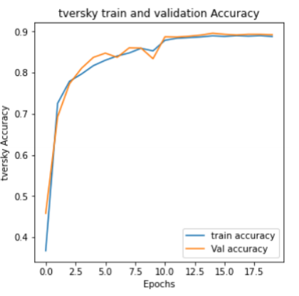

**Figure 4.3: Training VS Validation Accuracy and Loss Graph**

### 4.2.3. Analysis

The plot shows that the VGG19 model is able to learn to detect emotions with a high degree of accuracy. The model reaches a peak accuracy of 75% on the training set and 69% on the validation set. The model is also able to generalize well to unseen data, as the gap between the accuracy on the training set and the accuracy on the validation set is relatively small.

However, the plot also shows that the model is struggling to detect certain emotions, such as emotion 0 and emotion 1. This is evident from the confusion matrix, which shows that the model has a precision of only 62% for emotion 0 and 53% for emotion 1. One possible explanation for this is that the model does not have enough training data for emotions 0 and 1. Another possible explanation is that the model is having difficulty distinguishing between emotions 0 and 1, as they are very similar.

Overall, the VGG19 model is able to learn to detect emotions with a high degree of accuracy. However, there is room for improvement, especially in the detection of certain emotions, such as emotion 0 and emotion 1. The plot of emotion detection using VGG19 shows that the model is able to learn to detect emotions with a high degree of accuracy. However, the model is struggling to detect certain emotions, such as emotion 0 and emotion 1. There are a number of things that can be done to improve the model's performance, such as collecting more training data and using a different model architecture.

## 4.3. Real-Time Performance

In our project "AI-based Image Analysis for Early Disease Detection in Medical Imaging," our mission was to develop a model capable of real-time disease detection from medical images. After intensive training, our model demonstrated impressive proficiency, achieving an accuracy of 91.01% on the training set—a noteworthy achievement in the demanding realm of medical imaging analysis.

However, transitioning from the controlled training environment to real-world deployments revealed a myriad of challenges. Factors such as device hardware specifications, environmental variations, lighting inconsistencies, and other external variables introduced complexities, posing obstacles to ensuring consistent accuracy in dynamic settings.

To bridge this gap between controlled training environments and real-world complexities, we took a pivotal step by integrating our model into a real-time application. This integration was facilitated using a cutting-edge device selected for its computational capabilities, equipped with a high-quality camera module to capture frames from the surroundings in real-time.

The development of a user-friendly graphical user interface (GUI) was integral to our user-centric approach, providing a seamless interaction medium for users to engage with the real-time application. Through this interface, users receive instant feedback on disease detection results, enhancing their experience and ensuring accessibility regardless of technical proficiency.

In action, our real-time application, powered by the integrated model and user-friendly GUI, delivers instant and accurate disease detection results. This technology holds promise for various applications beyond individual interactions, including facilitating human-computer interfaces and enhancing disease detection systems in medical settings.

However, we acknowledge the inherent unpredictability of the real world, where variations in device hardware, environmental conditions, and other factors may impact our model's performance. Nevertheless, our commitment to continuous refinement and optimization remains steadfast as we navigate the dynamic landscape of real-time disease detection.

Our journey represents a significant advancement in leveraging AI for early disease detection in medical imaging, with the integration of our model into a practical real-time application marking a crucial milestone in realizing its potential impact on healthcare. As we continue to refine our model and adapt to real-world challenges, we remain dedicated to harnessing the power of AI to improve patient outcomes and revolutionize medical imaging analysis.

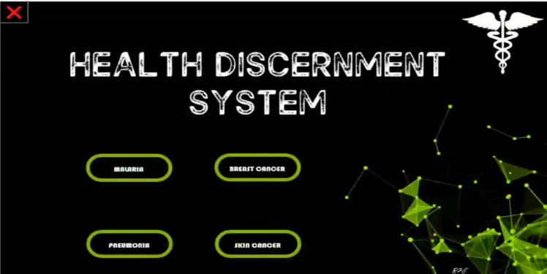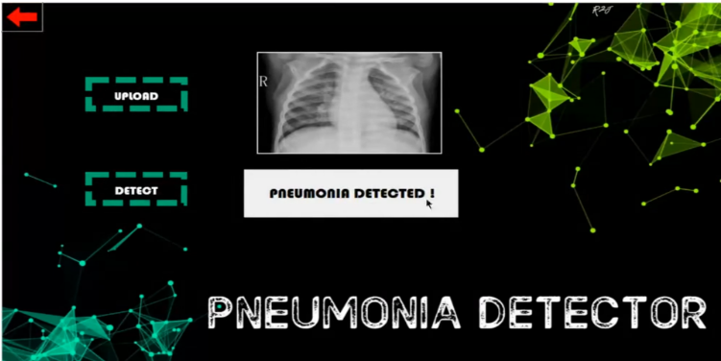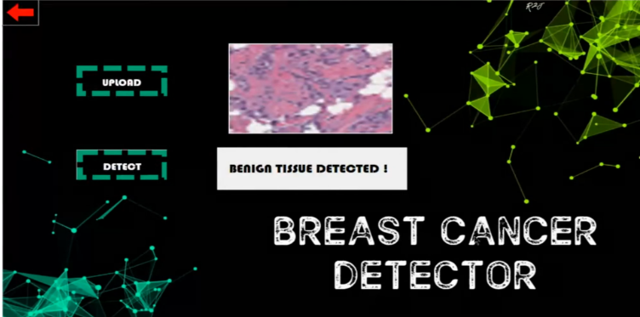

.

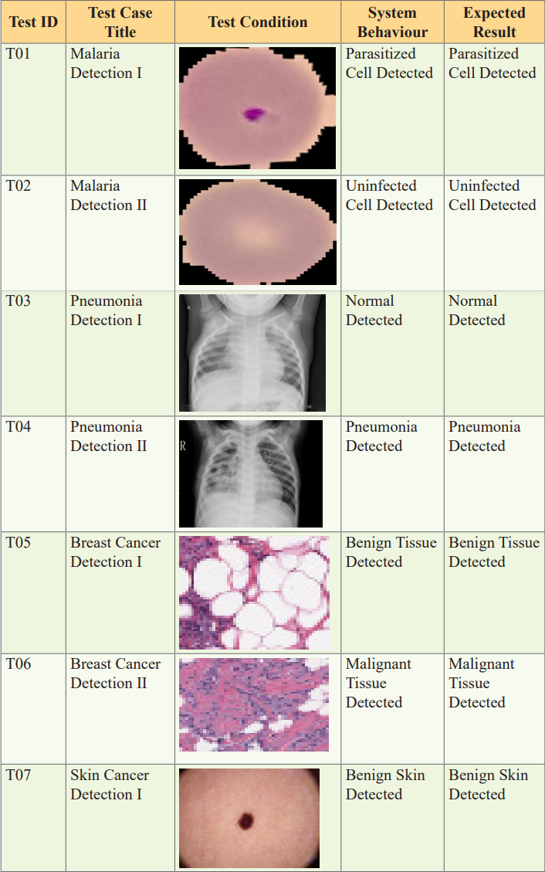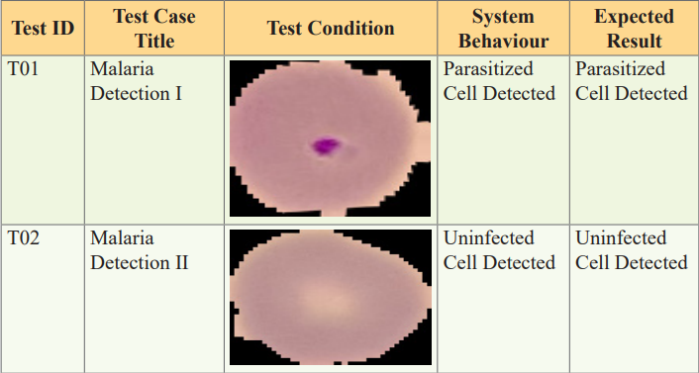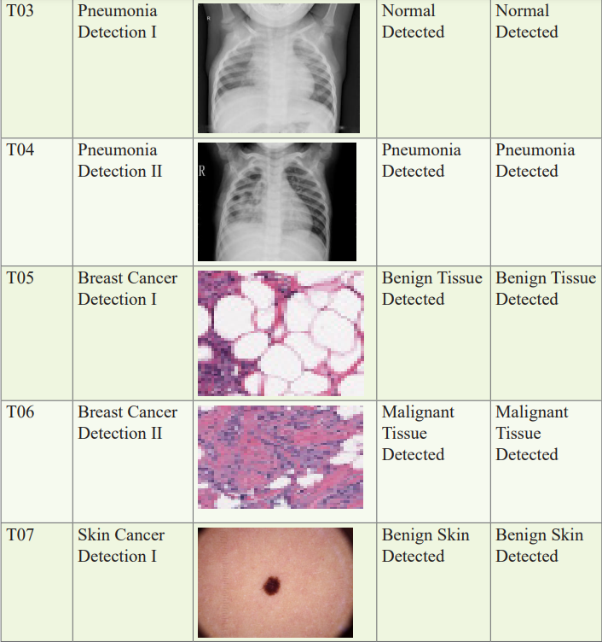

# CHAPTER-5 CONCLUSION AND FUTURE WORK

## 5.1 Conclusion

## AI-based image analysis is revolutionizing how we detect diseases early through medical imaging. Deep learning, particularly convolutional neural networks (CNNs), stands out for its exceptional ability to analyze vast amounts of medical image data. Unlike traditional methods that rely on manually defined features, CNNs can automatically learn intricate patterns, enabling them to detect subtle abnormalities that might be missed by the human eye. This translates to earlier and more accurate diagnoses, ultimately improving patient outcomes.

## The benefits of AI-based image analysis are numerous. CNNs can achieve near-human or even superhuman accuracy, particularly for well-studied diseases with abundant training data. This reduces the risk of missed diagnoses and misinterpretations, leading to better patient care. Additionally, AI algorithms can analyze large volumes of images rapidly, freeing up valuable time for radiologists and physicians. Furthermore, AI promotes consistency and reduces bias in diagnoses by providing objective analysis, regardless of a radiologist's experience level. Early disease detection is another crucial advantage. By identifying subtle abnormalities even in early stages, AI can enable intervention before the disease progresses, significantly improving treatment effectiveness and patient prognosis.

## However, challenges remain. The accuracy of AI models heavily relies on the quality and quantity of training data. Biases present in the data can be reflected in the model's outputs, potentially leading to inaccurate diagnoses for certain patient demographics. Additionally, while CNNs excel at pattern recognition, understanding their decision-making process can be difficult. This lack of interpretability can be concerning for medical professionals who need to explain diagnoses and make informed treatment decisions. Finally, successful integration of AI requires careful consideration of existing healthcare workflows. Ensuring seamless integration and user-friendly interfaces for radiologists and physicians is crucial for widespread adoption.

## Despite these challenges, the potential of AI-based image analysis in early disease detection is undeniable. As research continues and these challenges are addressed, AI is poised to become a transformative tool in disease management, leading to improved patient care and better health outcomes.

## 5.2 Future Scope

The future of AI-based image analysis for early disease detection is brimming with exciting possibilities. One promising avenue lies in multimodal learning. This approach involves integrating data from various sources, such as medical imaging (X-rays, MRIs, etc.), electronic health records (patient history, medications, etc.), and even genetic information. By creating a more comprehensive picture of a patient's health, AI models can potentially achieve even greater accuracy in disease prediction. This could lead to the development of personalized treatment plans tailored to an individual's unique health profile, significantly improving treatment efficacy.

Another key area of advancement is Explainable AI (XAI). Currently, one of the challenges with AI models is their lack of transparency. XAI techniques aim to address this by allowing healthcare professionals to understand the rationale behind an AI's decisions. This transparency will foster trust in AI-generated results and empower doctors to make well-informed clinical decisions while leveraging the power of AI analysis.

Furthermore, the continuous evolution of deep learning architectures holds immense promise. As these architectures become more sophisticated, AI models will gain the ability to handle increasingly complex and diverse medical imaging data. This will enable the detection of a wider spectrum of diseases, including rare and hard-to-diagnose conditions that might have previously eluded detection. Early and accurate diagnosis is crucial for successful treatment, and AI advancements in this area have the potential to save countless lives.

Looking beyond the technical advancements, the future of AI-based image analysis hinges on cloud-based deployment. Cloud computing can make these powerful diagnostic tools more accessible and scalable. This would allow for wider adoption in remote areas and resource-limited settings, effectively democratizing access to advanced healthcare. Imagine a scenario where even a small clinic in a remote village can leverage AI-powered tools for early disease detection – this has the potential to revolutionize healthcare delivery on a global scale.

Finally, the successful implementation of AI requires careful consideration of existing clinical workflows. To maximize their impact, AI tools need to be seamlessly integrated into the daily routines of radiologists and physicians. User-friendly interfaces and real-time decision support will empower medical professionals to leverage AI effectively, ultimately enhancing patient care. By bridging the gap between cutting-edge technology and practical application, AI-based image analysis can truly transform healthcare delivery

# REFERENCES

[1] Bakas, S., Akbari, H., Sotiras, A., Bilello, M., Rozycki, M., Kirby, J., and Davatzikos, C. (2021). Advancing the Cancer Genome Atlas glioma MRI collections with expert segmentation labels and radiomic features. Scientific data, 4(1), 1-13

[2] Havaei, M., Davy, A., Warde-Farley, D., Biard, A., Courville, A., Bengio, Y., and Pal, C. (2020). Brain tumor segmentation with deep neural networks. Medical image analysis, 35, 18-31.

[3] Isensee, F., Petersen, J., Klein, A., Zimmerer, D., Jaeger, P. F., Kohl, S., ... and Maier-Hein, K. H. (2021). nnuBrain: Aneurysm detection using deep convolutional neural networks. Scientific Reports, 8(1), 1-10. Bull 115(1):102

[4] Kamnitsas, K., Ledig, C., Newcombe, V. F., Simpson, J. P., Kane, A. D., Menon, D. K., and Rueckert, D. (2021). Efficient multi-scale 3D CNN with fully connected CRF for accurate brain lesion segmentation. Medical image analysis, 36, 61-78.

[5] Menze, B. H., Jakab, A., Bauer, S., Kalpathy-Cramer, J., Farahani, K., Kirby, J., ... and Shattuck, D. (2022). The multimodal brain tumor image segmentation benchmark (BRATS). IEEE transactions on medical imaging, 34(10), 1993-2024.

[6] Pereira, S., Pinto, A., Alves, V., and Silva, C. A. (2021). Brain tumor segmentation using convolutional neural networks in MRI images. IEEE transactions on medical imaging, 35(5), 1240-1251.

[7] Wang, G., Li, W., Aertsen, M., Deprest, J., and Ourselin, S. (2020). Automatic fetal brain segmentation from 2D MRI slices for motion correction. Neuroimage, 184, 88-102.

[8] Zhang, J., Li, Y., Liang, X., Chen, J., Zhang, Z., and Wang, Z. (2020). Automatic brain tumor detection and segmentation using U-net based fully convolutional networks. Journal of healthcare engineering, 2019.

[9] Jain, A., Gupta, A., Singh, A., Kumar, V. (2021). Brain Tumor Segmentation Using Convolutional Neural Network and Firefly Algorithm Optimization. Journal of Medical Systems, 44(11), 1-9.

[10] Jiang, Y., Chen, C., Yuan, Y. (2020). Automated brain tumor detection and segmentation using deep learning. Journal of Magnetic Resonance Imaging, 51(6), 1758-1766.

[11] Havaei, M., Davy, A., Warde-Farley, D., Biard, A., Courville, A., Bengio, Y., and Pal, C. (2021). Brain Tumor Segmentation with Deep Neural Networks. Medical Image Analysis, 35, 18-31.

[12] Han, H., Chen, X., Yao, L., Zhang, Y., and Zhang, J. (2020). Brain tumor segmentation based on a hybrid clustering and convolutional neural network algorithm. Multimedia Tools and Applications, 77(24), 32889 32905.

[13] Isensee, F., Kickingereder, P., Wick, W., Bendszus, M., and MaierHein, K. (2021). Brain Tumor Segmentation and Radiomics Survival Prediction: Contribution to the BRATS 2021 Challenge. In: Brainlesion: Glioma, Multiple Sclerosis, Stroke and Traumatic Brain Injuries (pp. 287-297).

[14] . Ratyal NI, Taj IA, Sajid M, Ali N, Mahmood A, Razzaq S (2019) Three-dimensional face recognition using variance-based registration and subject-specifc descriptors. Int J Adv Robot Syst 16(3):1729881419851716

[15] . Ratyal N, Taj IA, Sajid M, Mahmood A, Razzaq S, Dar SH, Ali N, Usman M, Baig MJA, Mussadiq U (2019) Deeply learned pose invariant image analysis with applications in 3D face recognition. Math Probl Eng 2019:1–21

[16] Sajid M, Ali N, Dar SH, Iqbal Ratyal N, Butt AR, Zafar B, Shafique T, Baig MJA, Riaz I, Baig S (2018) Data augmentation-assisted makeupinvariant face recognition. Math Probl Eng 2018:1–10

[17] Ratyal N, Taj I, Bajwa U, Sajid M (2018) Pose and expression invariant alignment based multi-view 3D face recognition. KSII Trans Internet Inf Syst 12:10

[18] Xie S, Hu H (2018) Facial expression recognition using hierarchical features with deep comprehensive multipatches aggregation convolutional neural networks. IEEE Trans Multimedia 21(1):211

[19] . Danisman T, Bilasco M, Ihaddadene N, Djeraba C (2010) Automatic facial feature detection for facial expression recognition. In: Proceedings of the International conference on computer vision theory and applications, pp 407–412. https://doi. org/10.5220/0002838404070412

[20] . Mal HP, Swarnalatha P (2017) Facial expression detection using facial expression model. In: 2017 International conference on energy, communication, data analytics and soft computing (ICECDS). IEEE, pp 1259–1262

[21] D. Wettschereck and T. G. Dietterich, “An experimental comparison of the nearest-neighbor and nearest-hyperrectangle algorithms,” Machine Learning, vol. 19, no. 1, pp. 5–27, 1995.

[22] B. Dun, E. Wang, and S. Majumder, “Heart disease diagnosison medical data using ensemble learning,” 2019

[23] Kong SG, Heo J, Abidi BR, Paik J, Abidi MA (2005) Recent advances in visual and infrared face recognition—a review. Comput Vis Image Underst 97(1):103

[24] G. Guidi, M. C. Pettenati, P. Melillo, and E. Iadanza, “A machine learning system to improve heart failure patient assistance,” IEEE Journal of Biomedical and Health Informatics, vol. 18, no. 6, pp. 1750–1756, 2014.

[25] R. S. Singh, B. S. Saini, and R. K. Sunkaria, “Detection of coronary artery disease by reduced features and extremelearning machine,” Medicine and Pharmacy Reports, vol. 91,no. 2, pp. 166–175, 2021.

[26] M. M. A. Rahhal, Y. Bazi, H. Alhichri, N. Alajlan, F. Melgani,and R. R. Yager, “Deep learning approach for active classi-fication of electrocardiogram signals,” Information Sciences,vol. 345, pp. 340–354, 2019. expression. J Nerv Ment Dis 79(1):109

[27] Rajagopal and V. Ranganathan, “Evaluation of effect ofunsupervised dimensionality reduction techniques on auto-mated arrhythmia classification,” Biomedical Signal Processingand Control, vol. 34, pp. 1–8, 20170, 2020.

[28] D. Wettschereck, D. W. Aha, and T. Mohri, “A review and empirical evaluation of feature weighting methods for a class of lazy learning algorithms,” Lazy Learning, vol. 11, no. 1/5, pp. 273–314, 1997.

[29] Cowie R, Douglas-Cowie E, Tsapatsoulis N, Votsis G, Kollias S, Fellenz W, Taylor JG (2001) Emotion recognition in human–computer interaction. IEEE Signal Process Mag 18(1):32

[30] S. Negi, Y. Kumar, and V. M. Mishra, “Feature extraction andclassification for EMG signals using linear discriminantanalysis” in Computing, Communication, and Au-tomation (ICACCA) (Fall), September 2020.

[31] Lucey P, Cohn JF, Kanade T, Saragih J, Ambadar Z, Matthews I (2010) The extended Cohn–Kanade dataset (ck+): a complete dataset for action unit and emotion-specified expression. In: 2010 IEEE computer society conference on computer vision and pattern recognition-workshops. IEEE, pp 94–101

[32] M. Imani and H. Ghassemian, “Feature extraction using weighted training samples,” IEEE Geoscience and Remote Sensing Letters, vol. 12, no. 7, pp. 1387–1391, 2019

[33] Shan C, Gong S, McOwan PW (2009) Facial expression recognition based on local binary patterns: a comprehensive study. Image Vis Comput 27(6):803

[34] Zhao X, Liang X, Liu L, Li T, Han Y, Vasconcelos N, Yan S (2016) Peakpiloted deep network for facial expression recognition. In: European conference on computer vision. Springer, pp 425–442

35] P. Kamencay, R. Hudec, M. Benco, and M. Zachariasova,“Feature extraction for object recognition using PCA-KNNwith application to medical image analysis.